Enhancing Problem Solving Skills in Operational Research: The Well-structured Problem Case Study

Sheila Cheng* and Heng Loke Siow**

The rapid development of the technologyhas continually increased the complexity of problems as the industries and society progress. Moreover, many studies have indicated that Malaysian graduates do not possess the required problem solving skills to meet these industrial and societal demands.In fact, the crux of Operations Research (OR) is to help people to make better and informed decision by providing a quantitative basis for decision. Furthermore, one of the significant OR characteristics is generally appliedto problems, specific and localisedin nature.Henceforth, the problem solving skills of Malaysian graduates could be enhanced if they learn how to solve OR problems effectively in their formal education. This paper explores the cognitive processes adopted by 42 Malaysian business degree undergraduates (BDU) in solving a well-structured (WS) OR problem. In-depth observations and interviews were conducted. The problem solving sessions using the ‘think aloud’ approach were audio- and video-recorded. The cognitive processes of the problem solvers were determined from their behavior and performance exhibited while they were delineating the concepts, proposition and strategies in their solution paths. The similarities and differences of solution paths adopted by the successful and unsuccessful problem solvers were also discussed. The findings from this study revealthat non-linear cognitive processes were adopted by the majority of the solvers. Successful solvers could recall, retrieve and relate the relevant concepts to the problem, while unsuccessful solvers were unable to comprehend the problem although they indicated that they had learnt the relevant concepts and knowledge.It is envisaged that due to the lack of acceptance in the past, these OR research findings could enlighten the academic community of the importance of equipping problem solving skills among Malaysian BDU students.

JEL Codes: A22, C61 and D29

Introduction

Have you ever asked yourself : “What is the most interesting and important thing we humans do with our thinking skills?”

Sinnott (1989, p.1) suggested “We solve problems”.

On the other hand, the complexity of problems has continually increased as the industries and society progress, along with the rapid development of the technology and intense global competition. The time scales available to solve problems are becoming shorter,too.

*Dr. Sheila Cheng, School of Management, Asia e University, Malaysia .
Email :sheila.cheng@aeu.edu.my
**Prof. Dr. HengLokeSiow, School of Graduate Studies, Asia e University, Malaysia. Email: hengloke.siow@aeu.edu.my

Funke (2013, p.2) commented, “(Our) society is in urgent need for new insight about the way human dealt with complexity and uncertainty.” The sustainability and growth of businesses depend very much on effective decision making and problem solving. Thus, the quality of decision making and problem solving become the critical factors for organisations to succeed.

In Malaysia,problem solving was regarded as an important skill in the development of human capital and upgrading of mental and intellectual capacity of a nation (Ninth Malaysia Plan, 2006).It was emphasized by the Ministry of Education and the public atlarge and regarded it as one of the important attributes of graduates.

However, it was reported that many of the graduates still lackproblem solving skill when they embark on their chosen career. In 2008, it was reported in the Malaysian news media that up to 100,000 fresh graduates could not secure a job six months after they had graduated from the university. In a recent report (2April 2014) from Organisation for Economic Co-operation and Development (OECD) on the results of the Programme for International Student Assessment (PISA) on creative problem-solving, Malaysia was reported to have fared poorly in the world student performance assessment test conducted in 2012, and one of the skills measured was on problem solving. Malaysia ranked number 39 out of the 44 countries participated, with a mean score of 422 compared to the overall mean score of 500 for all countries. This has caused an alarm in the country and there was a widespread of public opinion that Malaysia‟s education system needs revamping.Thus, this reiterated that students‟ acquisition of problem solving skills during their formal education still have much room to be researched and improved, especially among undergraduate business students who would soon be in the workforce as well as the future decision makers in the society.

Polya said that problem solving skills were not innate but something that could be taught (Long & DeTemple, 1996). Problem solving is considered as a superior cognitive skill acquisition (Renki & Atkinson, 2003). Al-Hudhaif (1998) and Huitt (1992) suggested the quality of problem solving and decision making can be improved through prescriptive steps and processes or even specific steps.

The need toprepare graduates ready for employment during their formal education is one of the major concerns in most of the educational institutions in Malaysia. It was noted that the crux of Operations Research (OR) is to help people to make better and informed decision by providing a quantitative basis for decision. It is generally applied to problems, specific and localised in nature. However, there is a dearth of research in Malaysia to relate OR concepts to the improvement of problem solving skills of business degree students. Henceforth, the problem solving skills of Malaysian graduates could be enhanced if they learn how to solve OR problems effectively in their formal education.

However, without understanding the thinking processes of students in solving problems, it would be difficult to teach students how to improve their problem solving skills. Thus, this study aims at investigating the cognitive processes of undergraduate business students (UBS) in solving well-structured OR problem.

The next section briefly discusses the literature on the characteristics of the wellstructured problems and the measurement of cognitive processes in problem solving using the Information Processing Theory (IPT). The methodolody on assessing the cognitive processes in solving the OR well-structured problem is discussed in Section 3. The results and findings are presented in Section 4, and the final section summarizes and concludes the section.

Literature Review

A problem is a “situation in which you are trying to reach some goal, and must find a means for getting there” (Chi & Glaser, 1985, p.229). According to Polya (1966), problem could be classified as either a “routine” or “nonroutine” problem. Routine means the solvers can find the solution easily by applying their skills without much difficulty, whereas those nonroutine types of questions are those more challenging problems requiring higher skills to solve. However, learners may have individual perceptions,in which one problem can be perceived as routine to one person but as nonroutine to another person.

According to Jonassen (1997), well-structured (WS) problems are problems that are welldefined and give clear goals for problem solvers to assess them in a logical manner. The characteristics of this type of problems are havinga known-goal state; possessing correct and convergent answer; as well as a preferred and prescribed solution process. Sinnott (1989) and Jonassen (2000) claimed that WS problems required only a limited number of concepts, rules and principles to solve, and usually have single or a limited number of correct solutions. Litzinger, et al., (2010)found that nearly all textbook type of problems are well-structured problems.

In education, problem solving is regarded as the most meaningful and important way of learning and thinking (Jonassen, 1997).Studies conducted by Lee (2003); Wang, Wang, Patel, & Patel (2006); Wang & Chiew (2010) asserted that problem solving was one of the basic life functions of the natural intelligence of the brain.

This paper attempts to relate key findings of a study on the cognitive processes that Malaysian business degree undergraduates (BDU) used in solving the well-structured Operational Research (WS-OR) problem, to provide an example of learning experience that identify the strategy in problem solving, to help learners to enhance their decision making and problem solving skills during their formal education, and to provide an insight into the instructional practices.
The first systematic study of human problem solving was reported by Newell and Simon in 1972. They published a book called “Human Problem Solving” which explained problem solving process from the approach of data processing. It outlined that people solved problems through a search of problem space that consists of the initial state, the goal state, and all possible states in between. They introduced the “think aloud” protocols and expected the participants to think aloud while solving a problem. Through a computer simulation programme which they have developed to solve the simple problems such as “Towers of Hanoi”, they analyzed how participants verbally evaluate cues to form a strategy. They pronounced that the problem solving processes are related with thinking processes and are composed of two stages: the realization of process and the research of process (Newell & Simon, 1972). Thus, an observed behaviour can be explained by specifying an information processing device that can reproduce that behaviour.

In another major study, Carpenter, Just and Shell (1990) explained the problem solving process by adapting the Raven tests and a theoretical model was henceforth developed. The process of Raven tests was compared to the Towers of Hanoi test which measures the cognitive processes. From observations made, they claimed that the purpose repetition strategy which is included in Hanoi Towers test is valid for Raven tests. From the findings of this study, it was claimed that “the ability of purpose repetition strategy is related to working memory; the purpose towards problem solving behavior was formed and sustained in working memory… Subjects‟ regularly repeating coding and inductive strategy enable and increase in their operation characteristics.”(Kadafar, 2012, p.197).

In the study of cognitive informatics, Wang and Chiew (2010) explained the relationship between human‟s data processing and natural intelligence with engineering application. They presented a mathematical and cognitive model of problem solving process which is called layered reference model of the brain. They asserted that cognitive process of problem solving starts with the identification of object. Subsequently, determination of features, alternative aims and choices are researched and quantified. Finally, with the evaluation of results, selection, satisfaction level of result, forming reaction and storage of knowledge are stored into the memory to complete the process. Problem solving is at a higher level of cognitive process, it interacts with many other cognitive processes such as abstraction, searching, learning, decision making, inference, analysis, and synthesis on the basis of internal knowledge representation (Wang and Chiew, 2010; Kafadar, 2012).

In the context of Malaysia, Beh and Abdullah (2003) did a study on college students solving Physics problems in electricity and reported that students were generally weak in solving parallel circuit problems.Another study did by Beh et al. (2006) on college students revealed that generally students were weak in conceptual understanding of Direct Proportion but high in procedural understanding. This reflected that students‟ problem solving skills were weak if they did not have the conceptual understanding. Another complementary study on inverse proportion,byBeh, Tong&Chee (2008) found similar results.

The study of human problem solving is the study of the human mind on information processing. When a solver proceeds to solve a problem, the mind interprets the input information, and begins to internalise the input and then represents the input in a sensible manner as output. As information is being processed, it would be useful to explore the underlying issues as to what extent the information is relevant, how the solver perceive the information and evaluate the information. In this regard, Information Processing Theory (IPT) was adopted in this study to expound the cognitive processes in solving WS-OR problem.This is the unique contribution of this study. IPT is a theory of learning developed by George Miller in 1956. It mainly describes the processes of human problem solving, characteristics of information system that carries out the processes and the nature of task environment in which the processes operate (Newell & Simon, 1972).

The Methodology and Model

This study employed a qualitative approach with a focus on phenomenography by observing a purposive sample of 42 UBS in solving the well-structured (WS) OR problem. Participants were selected from six universities/colleges in Malaysia.

Data were collected based on four steps. First, individual participant was introduced to the
“think aloud” method and a video clip. Participant then clarified any area in the video and confirmed his/her understanding. Second, the participant was interviewed with the structured questions on his/her personal background and degree of exposure to the OR problems. Third, participant was given the selected WS-OR problem with a brief explanation.Participant was also affirmed that no restriction on the approach in solving the given problem. Lastly, once a participant had completed solving the given problem, based on his/her works, he/she was interviewed with semi-structured questions retrospectively. The observations and face-to-face interviews were conducted to ensure that the researcher could obtain an in-depth and comprehensive information.By combining with the researcher‟s observations, field notes, participants‟ works and verbatim, data were then triangulated for analysis.

The Figure 1below indicates the WS-OR problem which was adopted as one of the main instruments to test the participants‟ cognitive processes in solving problem.

Figure 1: A well-structured operational research problem
A company is involved in the production of two items (X and Y). The resources needed to produce X and Y are twofold: namely, machine time for automatic processing and craftsman time for hand finishing. The table below gives the number of minutes required for each item:

 |  | Machine time | Craftsman time
Item | X | 13 | 20
 | Y | 19 | 29

The company has 40 hours of machine time available in the next working week but only 35 hours of craftsman time. Machine time is costed at RM10 per hour worked and craftsman time is costed at RM2 per hour worked. Both machine and craftsman idle times incur no costs. The revenue received for each item produced (all production is sold) is RM20 for X and RM30 for Y. The company has specific contract to produce 10 items of X per week for a particular customer.
Determine how much the company should produce per week.
(Adapted from Beasley, 2004, p.102)

The above-mentioned WS-OR problem is a management decision-making problem which involves certain level of complexity and uncertainty. Participants were examined to determine the required Management Science concepts and skills to solving it. It is about using optimization technique – Linear Programming (LP), which is a problem solving approach developed for situations involving maximizing or minimizing a linear function subject to linear constraints that limit the degree to which the objective can be pursued (Anderson et al, 2008, p. 16). It requires a clear understanding or exposition of the problem, as well as what can be achieved numerically.

To solve the above-mentioned WS-OR problem, the participant has to access his/her problem schema in order to obtain numeric solution as an optimal answer. In this study, participants were expected to demonstrate their cognitive processes by recalling their concepts and propositions of LP to solve this problem, although no restriction on the method to be used.

This problem consisted of two components: (a) formulation of mathematical model and (b) solution. Although solution approaches could exist in varied forms, one of the approaches to this problem was to adopt the optimization technique through the graphical approach.
This was the basic approach taught in the business degree programme, and was adopted in the marking scheme as a guide to indicate the generic solution path. The formulation component consisted of defining variables, constructing constraints functions, setting objective function as well as the non-negativity of variables. The approach to the graphical solution was to turn all inequality constraints into equalities and using these equations to draw the corresponding lines on the graph. Once a line had been drawn, then the participants would be required to work out which side of the line corresponds to all feasible solutions to the original inequality constraint. Then a dotted iso-profit line was drawn to indicate the optimal solution to the linear programming (Anderson, Sweeney, Williams, & Martin, 2012).

All written answer scripts were reviewed and marked to determine the cognitive processes with a focus on the participants‟ use of approach and strategies adoption to solve the WSOR. These included taking into consideration the participant‟s application of concepts and propositions, knowledge and decision making as part of the data analysis. The following Figure 2 showed the scores obtained by participants in solving the WS-OR problem, and the distribution of their marks respectively. The distribution of marks does not follow a normal distribution due to limited sample size available.

Figure 2: Distribution of marks of participants solving the WS-OR problem
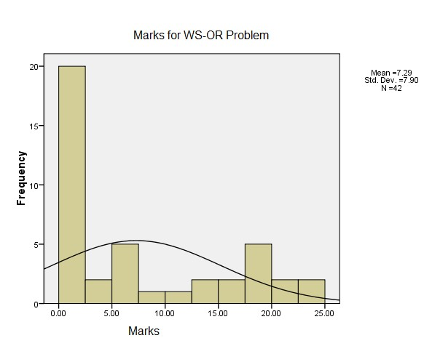
The participants were then categorised into Successful Solvers (SS) and Unsuccessful Solvers (US) based on the scores awarded on their answer scripts. A total mark of 25 was awarded for the entire problem. A score of 10 marks ( 40%) was the cut-off point and a script awarded 12 marks or more was considered as successful in solving the problem, otherwise it was considered as an unsuccessful attempt. This 40% passing rate was benchmarked against the passing rate used by the colleges/universities under this study.
To examine the participants‟ cognitive processes, the decision making and problem solving strategies developed by Anderson, et al (2012) was used to code the problem solving processes of participants in solving the problem. Anderson et al‟s decision making and problem solving model indicated that problem solving is a process which consists of 7step. The 7-step strategies as shown in Figure 3 are : Step 1) Identify and define the problem; Step 2) Determine the set of alternative solution; Step 3) Determine the criterion; Step 4) Evaluate the alternatives; Step 5) Choose an alternative; Step 6) Implement the decision; Step 7) Evaluate the results.

Figure 3: The relationship between problem solving and decision making

Problem Solving

Decision Making

Decision

Define the Problem

Identify the Alternatives

Determine the criterion

Evaluate the Alternatives

Choose an Alternative

Implement the Decision

Evaluate the Results

In this study, it is noted that the cognitive processes adopted by problem solvers in solving the WS-OR problemwere similar but not identical to Anderson et al‟s decision making and problem solving model. It was observed that the degree of resembling the processes was highly dependent on the retrieval of OR knowledge in the long term memory. Retrospection was exhibited when the problem solvers encountered anomalies. The details will be discussed in the next section.

The Findings

There were 42 participants attempted to solve the given WS-OR problem. It was found that 33% (or 14) participants who had successfully solved the WS-OR problem and they were classified as successful solvers (SS) and 67% (or 28) participants who were not able to solve the problem and were categorised as unsuccessful solvers (US). The solution indicated that although there was no restriction on the method used in solving the problem, about half (20) of the participants had used the graphical solution approach and 12 of them had solved the problem through drawing diagram (on graph paper). However, only nine out of the 12 had successfully obtained the solution from the diagram while three others made mistakes in drawing diagram. The rest (22 participants) had used other approaches and majority of them adopted deduction or reasoning method based on their prior knowledge, other than five who adopted the Economic propositions approach. Table 1 shows the summary of methods employed by participants to solve the WS-OR problem.

Table 1 : Summary of Methods Employed by Participants to Solve the WS-OR Problem
WS-OR  problem | Total No. | Correct  (Final)  Answer |  | Methods |  | Draw Diagram on graph paper
 |  |  | Graphical | Non-graphical
 |  |  |  | Economic propositions method | Deduction /Reasoning method  (selfcreated method)
Successful Solvers (SS) | 14 | 8 (6 graphical and 2 nongraphical) | 12 | 2 | 0 | 12
Unsuccessful Solvers (US) | 28 | n/a* | 8 | 3 | 17 | 0
*n/a : not available
Among the 14 successful solvers (SS) who managed to solve the WS-OR problem, 12 adopted the graphical method with six arrived at the final correct answer, while the other two who adopted the non-graphical method, both obtained the final correct answer. About 89% (eight) graphical method solvers revealed retrospection in their problem solving processes, while 50% (one) non-graphical method solver revealed retrospection in the problem solving processes. Although the number of SS who adopted graphical method is higher than the number of SS who adopted the non-graphical method, it seemed that nongraphical method yielded a higher efficiency rate (100%) to arrive at the final correct answer than the graphical method (75%). However, the sample size is too small to make further conclusion on the method adopted.

There were 28 participants not able to solve the WS-OR problem, although all attempted to solve the problem. More than 70% (~20 participants) of the US adopted the approach based on their prior knowledge and interpretation. The remaining participants (8 participants) adopted a graphical solution approach which was taught in their degree programme.

Based on the categories mentioned in the Table 1, the cognitive processes of SS and US in solving the WS-OR problem were explored through three perspectives: (a) to identify the solution path based on participants‟ written work; (b) to describe the solution path based on the triangulated information from participants‟ „think-aloud‟ verbatims, retrospection from the interviews and the researcher‟s field notes; besides, the solution path was also presented in a flow chart to depict the flow of the thoughts of the solvers (c) to summarise the solution path into a problem solving process by resembling to the 7-step problem solving process postulated by Anderson et al (2012). Attention was also devoted to the step(s) which could reveal thebehaviour of retrospection in the process of problem solving.

The Cognitive Processes of Successful Solvers

The cognitive processes of SS were presented here by a selected sample ofHSP001 who adopted the graphical method in solving the WS-OR problem andare presented in the Exhibits 1, 1A and 1B.
Successful solver HSP001 attempted the problem by reading the question first and then underlined key words, setting the objective function, followed by constructing the constraint functions (inequalities). Then, she solved the first and second inequality and obtained four solution points. She drew x-axis and y-axis and plotted two lines based on the four solution point. She referred back to the problem and realised she had made a mistake on the unit of time scale. She then reviewed her work and made adjustment to the objective function, and crossed out the constraints set earlier. By re-setting constraints, she solved the inequalities to arriveat four new solution points. She then drew x- and yaxis on a new graph paper and plotted two lines. Subsequently, she identified and shaded the feasible region on the diagram. After that, she assumed a value (of 100) for the objective function and solved the objective function to obtain another two solution points. A dotted line (trial profit line) was drawn and an optimal point was identified within the feasible region.

The problem solving processes from SS HSP001 can be summarized in the Exhibit 1B. It was noted that the problem solving processes adopted by successful solver HSP001 to solve the WS-OR problem was similar to Anderson et al‟s (2012) 7-step problem solving process, except steps on the retrospection such as RE-determine the objective function,RE-determine the set of alternatives, RE-evaluate the alternatives and REchoose the alternative.

Exhibit 1: The Solution Path of HSP001(SS) in Solving the WS- OR Problem
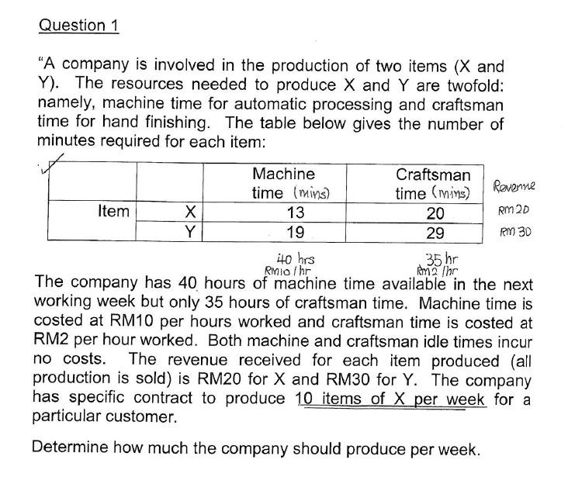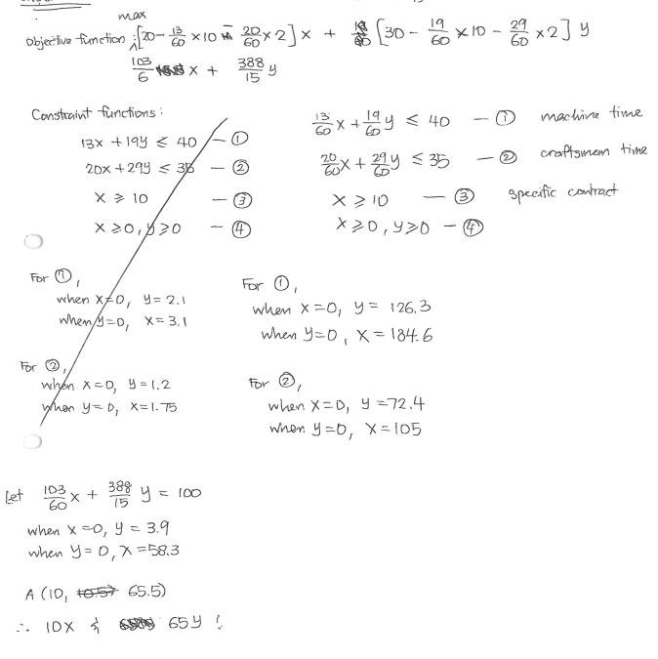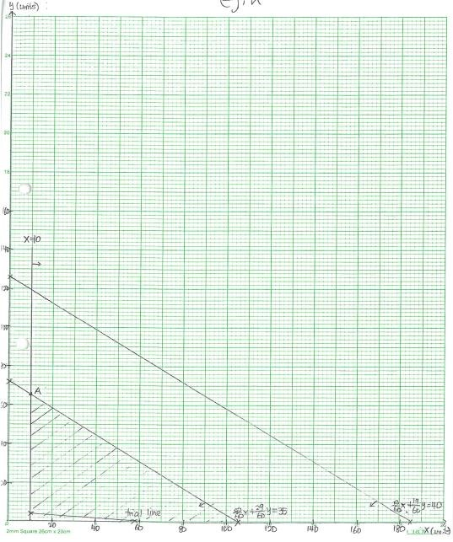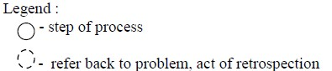

1

5

2

3

4

6

7

8

9

10

11

12

13

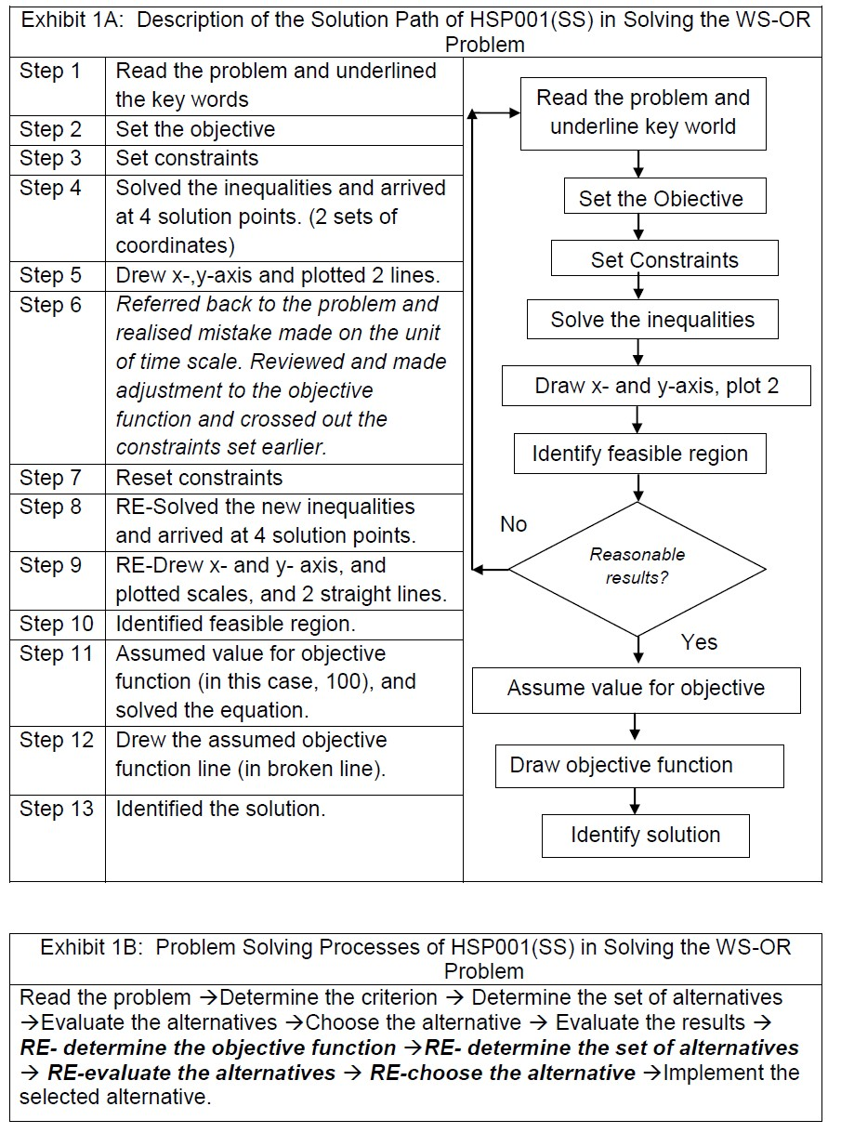

The Cognitive Processes of Unsuccessful Solvers

Among the 28 unsuccessful solvers (US) who attempted the WS-OR problem, about 29% (or 8) adopted the graphical method to solve the problem. Except two participants who forgot the Linear Programming method, the other six US could not solve the problem and could not arrive at the final correct answer due to various mistakes such as:(a) oversight the different units of time scale (minutes verses hours) given in the problem, (b) did not know what to do with the information of cost and revenue given in the problem, (c) missed out working steps. As a result, they made mistakes in the construction of constraints and/or objective function and could not solve the problem to arrive at the final correct solution. Having said that, 29% of the US adopted the graphical method to solve the problem, however, none of them attempted to sketch graph to obtain the solution. This might be due to the fact that they could not solve the inequalities successfully.

A selected sample of the cognitive processes demonstrated by unsuccessful solvers HTR019 in solving the WS-OR problem is outlined in Exhibit 2, 2A and 2B.

Unsuccessful solver HTR019 attempted the problem by first reading and identifying the problem, and then determining the constraints and evaluating the constraints. While evaluating the constraints, she realized the mistake made in units (minutes and hours). She referred to the problem again and re-set the constraints. Then she continued to evaluate the set of constraints. However, she then realised it was not feasible to carry on due to the variable being in negative value. She revisited to the problem again, but felt confused and stopped.

The problem solving processes of HTR019 (US) in solving the WS-OR problem could be summarised as follows in Exhibit 2B.

In the case of US HTR019, the problem solving processes resembled Anderson et al‟s (2012) 7-step problem solving process, except steps on retrospection such as Realised mistake and RE-identified the problem→ Re-determine the set of alternatives → Reevaluated the alternatives →Realised not feasibleRE-identified the problem→ Redetermine the set of alternatives → Re-evaluated the alternatives. Retrospection, in the case of HTR019 (US) started from the step where mistake was first found in solving the inequalities.

Exhibit 2: Solution Path of HTR019 (US) in Solving the WS-OR Problem
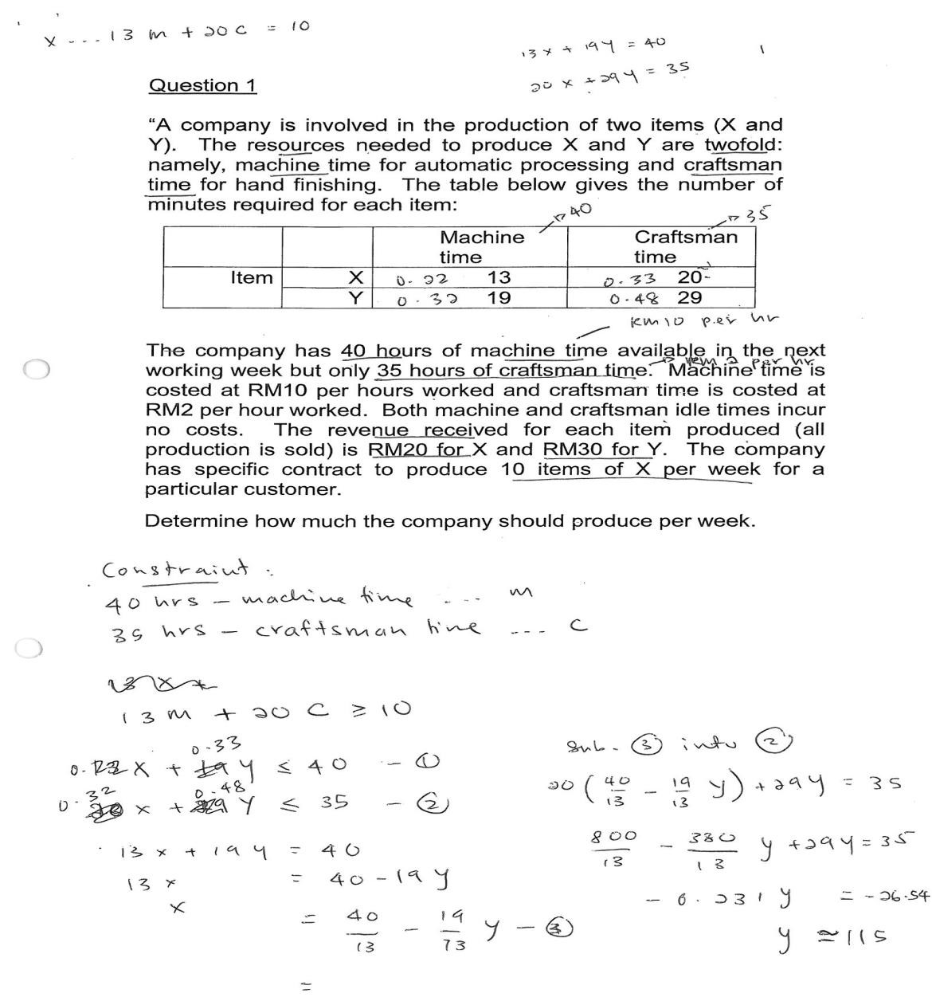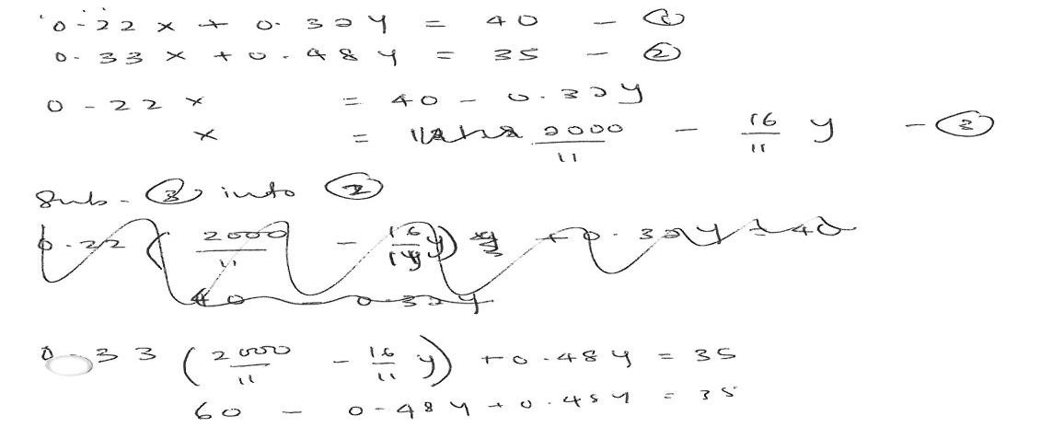

1

2

3

4

5

6

7

8

10
9

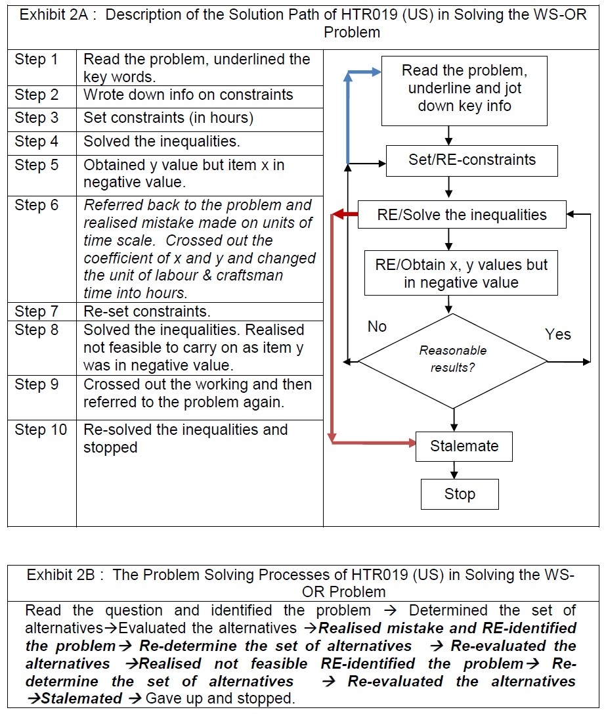

It was also noted that there was a difference in the time taken by the SS and US. Table 2 provides the distribution summary statistics of time taken for participants to answer the WS-OR problem. The mean time taken by SS was 27.25 minutes with a standard deviation of 10.39, while the mean time taken by US was 15.95 minutes with a standard deviation of 6.57. The large value of the standard deviation implies that SS have a wider variation of time taken to solve the WS-OR problem. This is further supported by a median of 23.58 minutes and 14.76 minutes, as well as a range of 34.83 minutes and 27.55 minutes respectively. The SS spent more time (1.7 times in average) than US in solving the WS-OR problem.

Table 2: Summary Statistics for Time Taken to Solve the WS-OR Problem
 | Unsuccessful Solver (US) (in minutes) | Successful Solver (SS) (in minutes)
Number of Respondents | 28 | 14
Mean (in min.) | 15.95 | 27.25
Median (in min.) | 14.76 | 23.58
Mode | 5.55ª | 12.25ª
Std. Deviation | 6.57 | 10.39
Variance | 43.17 | 108.05
Range (in min.) | 27.55 | 34.83
Minimum (in min.) | 5.55 | 12.25
Maximum (in min.) | 33.10 | 47.08
Multiple modes exist. The smallest value is shown

Based on the two mean values, it was interesting to note that the time taken by the US was shorter than the SS. From the observations made on the participants‟ behaviours and interviews with them, many admitted that they were not sure if they had solved the problem correctly. They felt confused and did not know how to deal with the cost and revenue (simultaneously) given in the problem, especially the last sentence in the problem “The company has specific contract to produce 10 items of X per week for a particular customer.” They just approached the problem based on their prior knowledge and arrived at the answer arbitrarily.

A Mann-Whitney U test through the SPSS version 16 was conducted to determine whether there was any significant difference in the time taken between the SS and US in solving the WS-OR problem . Following Table 3 indicates the test results of Mean Ranks and the Mann-Whitney U test.

Table 3 : Mean Ranks and Mann-Whitney U test of Time Taken by Participants Solving the WS- OR Problem
Participants | Mean Rank | Chisquare | Z-value
Successful solvers (SS) | 30.71(14) | 67.00* | -3.442
Unsuccessful solvers (US) | 16.99 (28)
* Chi Square significant at p < 0.001

Results of Mann-Whitney U test reveal that the difference in time in solving WS-OR problem between the SS and US was significant at p < 0.001. The results indicate that the successful solvers took a significantly longer time in solving the WS-OR problem compared to the US. This result is consistent with the statistics described in Table 2.

Analysis

It was found that both successful and unsuccessful solvers adopted similar strategies in solving the problem but have used a variety of approaches such as graphical, nongraphical, economic model, etc, when solving the WS-OR problem.

Their solution paths demonstrated that they closely resembledto Anderson et al ‟s problem solving model. Most of the successful solvers exhibited nearly all the steps of the problem solving models, while the unsuccessful solvers might stop at various stages of the decision making process. However, they did not resemble the steps in a sequential/algorithmic manner. Retrospection would occur at any step when problem solvers encountered anomaly, and not necessarily at the final stage of problem solving processes.

Prior knowledge related to OR was recalled and demonstrated through the different pause points and thinking behaviours such as scratching heads, flipped the pen, etc. This was a reflection on the retrieval of long term memory (LTM) of participants‟ OR knowledge.

Two phenomena were observed in the work of successful solvers: (a) majority of the successful solvers (86%) used the graphical approach and were able to recall systematic steps as to what had been taught or had been learnt in their subject; (b) many successful solvers (64%) solved the problem and identified the solution correctly through a diagram. This seemed to suggest that adopting the graphical approach generated a higher successful rate in this WS-OR problem solving.However, this might be due to the fact that graphical method is among the popular methods taught in participants‟ formal education, and participants were able to recall this method with ease when they had good memory of this method. On the contrary, in the case of US, they remembered the Linear Programming (LP) method but could not recall its algorithm, hence they could not solve the problem and finally gave up.

As for the unsuccessful solvers, three phenomena were observed in the process of solving the WS-OR problem: (a) many participants (36%) claimed that they were aware of such problem but they had forgotten how to solve it. Although they studied the topic of Linear Programming some time ago (the longest period was two semesters ago, and shortest period was two weeks ago), they claimed that they had forgotten how to solve the problem. This could be explained by the Information Processing Theorythat some participants could not retrieve the stored information from their long-term memory into working memory for further processing; (b) many unsuccessful solvers (50%) claimed that they did not understand the statement “the company has a contract of 10 items x”. This was the critical part in which they did not know how to structure it into one of the constraints. This might be due to lack of OR knowledge or language barrier; (c) many unsuccessful solvers (75%) missed accounting for the different units of machine time and craftsman time stated in the WS-OR problem. This might be attributed to oversight or careless.

The distinctive behaviour between the SS and US was that successful solvers took an average of 11.3 minutes longer time than unsuccessful solvers (27.25mins - 15.95mins) in solving the WS-OR problem. This is supported by the Mann-Whitney U test on time significance with mean ranks ² =67, p≤0.001.
Although the statistics show that the longer a participant was exposed to the field, the higher the probability that he/she would be able to solve the problem successfully, this may be just a general rule of thumb. However, this study seemed to suggest that relevant knowledge helps develop creativity in solving similar problems. When participants could not recall the “formula”, they would resort and retrospect to other relevant knowledge stored in the memory and then work on it according to their logical ways.

It was also noted that the main difference between SS and US was very much dependent on the individual‟s OR knowledge, problem understanding and mathematical ability, rather than the method employed. This was consistent with the studies done by Lesh and Harel (2003), and Litzinger, et al.(2010) who found that learning and problem solving were intertwined. “Knowledge influenced the problem solving strategies learners use, and the strategies used influence what knowledge was gained from the problem solving experience.” (Litzinger, et al., 2010, p.338)

Information stored in the memory might be lost as mentioned in the IPT, this also explained that why some participants could not retrieve their stored information (or so called “formula”) to solve the WS-OR problem. And if they failed to retrieve the “formula”, they encountered anomaly and could not carry on so they gave up.

Conclusions

As a conclusion, although the cognitive processes of both SS and US were similar in solving the WS-OR problem, the processes in solving the problem did not demonstrate a sequential/algorithmic pattern. Retrospection was frequently exhibited in any step when problem solvers encountered anomaly. The retrieval of long term memory (LTM) of the participants‟ OR knowledge played an important role in the success of problem solving.

In this study, participants solved the WS-OR problem following a “guided” pattern of problem solving method, which some participants called it as “formula”. After reading the problem, participants tended to recall the “formula” and followed accordingly. Once they failed to recall, they would then retrospect to other relevant knowledge and used deduction method to obtain some answers. In addition, due to following the “formula” method, participants knew that there existed a fixed/correct answer. Participants tended to search and conform to the “correct” answer. Retrospection was revealed whenever they encountered anomaly.

This indicated two significant areas which might give some insights to instructors in teaching the OR subject. Firstly, to solve the WS-OR problems, which are quantitative in nature, mathematical knowledge is important, the ability to integrate the information given in the problem and formulate a mathematical model of real-world situation is the determinant factor.

Secondly, the relevant knowledge acquired (or apriori knowledge) which acts as a rich resource of information in the long-term memory (LTM) is another determinant factor. The distinctive behaviour between the SS and US was that SS took longer time than US in solving the WS-OR problem. This is supported by the Mann-Whitney U test on time significance.

In view of strategies adopted by all participants in solving the WS-OR problem, Anderson et al‟s 7-step decision making and problem solving model was coded. Majority of SS seemed to depict each strategy very closely, but not for the US. The series of strategies employed did not follow a sequential manner.

On the other hand, this study seemed to indicate that the participants who adopted the graphical method had a higher success rate in solving the problem. This could be attributed to the fact that the cognitive processes of participants were bounded by a set of heuristic steps or guided “formula”, and if they failed to recall this set of “formula”,they might not be able to solve it successfully. Only few participants could find an alternative solution otherwise. This could be due to the lack of problem solving skills. These findings were in congruence with the study done by Yunus, et al. (2006) who found that Malaysian university students lacked generic skills in problem solving, specifically in definition and formulation of problems, in generation of alternatives subscale, in decision making and in implementation and verification of the solution.

Although the findings of this study are limited by a small sample size and might not be generalisable enough to a wider context, the findings however may be able to contribute to the further understanding of cognitive processes in problem solving, particularly those related to OR problems.

References

Al-Hudhaif, S 1998,A visual interactive goal programming-based decision support system: An empirical assessment. ProQuest Dissertations and These 181.
Anderson, DR, Sweeney, DT, Williams, A, Martin,R 2008,An Introduction to Management Science : quantitative approaches to decision making, 12th ed, Thomson South Western, Canada.
Anderson, DR, Sweeney, DT, Williams, A, Camm, J, & Martin, R 2012,An introduction to Management Science : quantitative approaches to decision making, Mason: SouthWestern Cengage Learning.
Beasley, J 2011,Study Guide for Management Science Methods, University of London International Programme, University of London Press.
Beasley, J (n.d.),OR-notes,viewed March 30, 2014, from:
<http://people.brunel.ac.uk/~mastjjb/jeb/or/intro.html>
Beh, K 2006,College students? Alternative frameworks in the six domains of direct proportion, Faculty of Education, University Malaya, Malaysia.
Beh, K, & Abdullah, N 2003,„The effect of physics instruction on conceptual change and problem-solving in the domain of electric circuits among high-achiever college students‟,Esteem Academic Journal, vol.1, pp.11-20.
Beh, K, Tong, S, & Chee, N 2008, A study on the developmental changes in conceptual understanding and problem solving skills in inverse proportion among college students in terms of academic ability and genders difference,Universiti Teknologi Mara, Malaysia .
Carpenter, P, Just, M, & Shell, P 1990, „What one intelligence test measures, a theoretical account of the processing in the Raven Progressive Matrices Test‟,Psychological Review, vol. 97, no. 3, pp. 404-431.
Chi, M., & Glaser, R 1985,„Problem solving ability‟, in RJ Sternberg (ed), Human abilities : an information processing approach, New York: W.H. Freeman, pp.227-250
Funke, J 2013,„Human Problem Solving in 2012‟,Journal of Problem Solving, vol. 6, no.1, pp. 2-18.
Huitt, W 1992,„Problem solving and decision making: Consideration of individual differeces using the Myers-Briggs Type Indicator‟, Journal of Psychological Type, vol. 24, pp. 33-44.
Jonassen, DH 1997,„Instructional Design Models for Well-Structured and Ill-Structured Problem-Solving Learning‟, ETR&D, vol. 45, no.1, pp. 65-94.
Jonassen, DH 2000, „Toward a design theory of problem solving‟,Educational Technology Research and Development, vol. 48, no. 4, pp. 63-85.
Kadafar, H 2012, „Cognitive Model of Problem Solving‟,New/Yeni Symposium Journal, pp.195-206.
Lee, S2003,„Cognitive and megacognitive processes in solving geometric problmes‟,PhD thesis, University of Malaya, Malaysia.
Lesh, R & Harel, G 2003,„Problem solving,modeling, and local conceptual development‟, Mathematical Thinking and Learning, vol. 5, no. 2-3, pp. 157-189.
Litzinger, TA, Meter, PV, Firetto, CM, Passmore, LJ, Masters, CB, Turns, SR, et al 2010„A Cognitive Study of Problem Sovling in Statics‟,Journal of Enginerring Education, vol. 99, no.4, pp. 337-353.
Long, C & DeTemple, D 1996,Mathematical reasoning for elementary teachers. Reading MA, Addison-Wesley.
Newell, A & Simon, H 1972,Human prolbem solving, Prentice Hall: Englewood Cliffs, N.Y.Ninth Malaysia Plan, The Economic Planning Unit 2006, Malaysia.
Organisation for Economic Co-operation and Development (OECD), PIZA 2012 Results : Creative Problem Solving - Students' skills in tacking real-life problems Volume V, viewed April 4th April, 2014,
<http://www.themalaysianinsider.com/malaysia/article/malaysia-ranks-39-out-of-44countries-in-problem-solving-test-for-15-year-o>
Poly, G1966,„On teaching problem solving‟, In E. G. Begle (Ed.), The role ofaxiomatics and problem solving in mathematics, pp. 123-129, Boston, MA, Ginn.
Renki, A & Atkinson, R 2003, „Structuring the Transition From Example Study to Problem Solving in Cognitive Skill Acquisition: A Cognitive Load Perspective‟, Educational Psychologist, vol.38, no. 1, pp.15-22.
Schunk, DH 2008, Learning Theories : An educational perspective. N.J.: Pearson.
Sinnott, J 1989, Everyday problem solving: Theory and Applications. New York: Praeger.
Wang, Y & Chiew, V 2010, „On the cognitive process of human problem solving‟, Cognitive systems Research, vol.11, no.1, pp. 81-92.
Wang, Y, Wang, Y, Patel, S, & Patel, D 2006,„A layered reference model of the brain (LRMB)‟,IEEE Transactions on Systems, Man, and Cybernetics (C), vol.36, no.2, pp.124-133.
Yunus, AS, Hamzah, R, Tarmizi, RA, Abu, R, Nor, SM, Ismail, H, et al 2006, „Problem Solving Abilities of Malaysian University Students‟,International Journal of Teaching and Learning in Higher Education, vol. 17, no.2,pp.86-96.

