Enhancing the Problem Solving Skills of Decision Science Learners

Sheila Cheng
Asia e University

Fung Han-Ping
Hewlett-Packard Malaysia

Abstract:

With the increasing complexity of our society, problem solving skills have been admittedly acknowledged by employers as one of the critical and crucial soft skills sought-after attributes in their recruitment of employees. Many studies have claimed that decision makers need to possess different problem solving skills to approach and solve different types of problems. How can a person‟s solving skills be enhanced to the level that could lead to better decisions in an organization? Decision Science is a discipline which intends to help decision-makers to think more clearly about complex issues in their organisations, and on achieving committed alignment of key players. This paper attempts to explore the cognitive processes of successful problem solvers in solving the Decision Science problems. A sample of 42 undergraduate business degree students was used in this study in solving both well-structured and ill- structured Decision Science problems. „Think aloud‟ approach was audio- and video- recorded in the problem solving sessions. Results revealed that the cognitive processes of successful solvers followed a set of algorithms. This provides an insight for educators and instructional designers to enhance learners‟ problem solving skills in their formal education.

Introduction

Problem solving is regarded as an important skill in the development of human capital and upgrading of mental and intellectual capacity of a nation (Ninth Malaysia Plan, 2006). It is also increasingly recognized by employers as one of the critical and crucial soft skills attributes in their recruitment of employees. Decision Science (or called Operational Research) and problem solving goes hand in hand. It is widely used in industries, notably finance, pharmaceutical, healthcare, economics, and manufacturing. It helps problem solvers to develop a structured approach to assess corporate issues, developing solutions, and making effective decisions that drive the successful achievement of corporate objectives. In a nut shell, the zeal of Decision Science is to help improving the quality of decisions about managing valuable but limited resources.

In the context of Decision Science (DS), problem solving was referred as “the cognitive processes of identifying differences between the actual and the desired state of affairs and then taking action to resolve the differences” (Rosenhead, 2001, p.15).

Success leaves invaluable footprints. It is believed that by understanding the cognitive processes of the successful problem solvers, a pattern might be able to be developed to enhance the problem solving skills of the DS learners. This is supported by many researchers that the success of getting the solution during problem solving is associated with certain mental discipline of the solver. The quality of problem solving and decision making can be improved through prescriptive steps and processes or even specific steps. (Albert, 1996; Al-Hudhaif, 1998; Bernadette, Elizabeth, Linda, & Roger, 1994; Cai, 1994; Huitt, 1992; Lee, 2002, Polya, 1954; Schoenfeld, 1992; Wallas, 1926; Wang, Wang, Patel, & Patel, 2006; Wang & Chiew, 2010; Wilson & Clark, 1988).

This paper attempts to explore the cognitive processes of successful problem solvers who were selected from a group of 42 business degree students in Malaysia‟s higher institute of learning in solving the Decision Science problems. This is to identify the approach and strategy in problem solving, so that the problem solving skills of learners could be enhanced by following their footprints, meanwhile, to provide educators and instructional designers an insight in the curriculum delivery and development.

This paper was organised in five sections. The literature review on theory and measurement of cognitive processes in problem solving were firstly dicussed, followed by the methodology on assessing the cognitive processes in solving the DS problems. Thirdly, the results/findings was analysed in Section 4, and followed by Section 5 that summarized and concluded the exploration.

Literature Review

Research on problem solving can be traced back to its first study done by Edward Thorndike, the behaviour psychologist, when he embarked on the study of animal intelligence in 1913. In his study, the mind was described as having the ability to internalise and act out to connect stimuli and responses which originated in the environment. His work on animal behaviour and the learning process led to the theory of connectionism was subsequently grounded in Ivan Pavlov‟s work on conditioned reflexes, which dominated the basic research on cognitive processes.

On the contrary, the Gestalt psychologists believed that mental experience was dependent on the organisation and patterning of experience and one‟s perceptions (Ellis and Hunt, 1993). They related human problem solving ability to learning and perception (Ormrod, 1999). They postulated that perception is the product of complex interactions among various stimuli. Through our senses, human minds consider objects in their entirety instead of individual parts. When the problem is viewed in different perspectives, the solution can be found with a momentary insight or realization (Kafadar, 2012).

The disagreements between the behaviourists and Gestalt psychologists were philosophical and intractable. “It is not clear that they could ever have been resolved through empirical investigation.”(Ohlsson, 2012, p.103).

In the event, conceptual developments were made irrelevant due to WWII.
In 1943, Kenneth J.W. Craik wrote “The Nature of Explanation” and he explained the concept of mental models as “symbolism” (models of reality). He described that the symbolism was familiar to human brain but in mechanical devices. There was no research methods designed specifically for problem solving in the study of psychology in 1950. As a result, what little was known about how professional problem solvers such as engineers, managers, etc. solving unfamiliar problems came from introspective reports from the thinkers themselves (Ohlsson, 2012).

After nearly 20 years, the first systematic study of human problem solving was reported by Newell and Simon in 1972. They published a book called “Human Problem Solving” which explained problem solving process from the approach of data processing. They developed the problem space theory of problem solving, which outlined that people solved problems through a search of problem space. Problem space consisted of the initial state, the goal state, and all possible states in between. They introduced the “think aloud” protocols and expected the participants to think aloud while solving a problem. They pronounced that the problem solving processes are related with thinking processes and are composed of two stages: the realization of process and the research of process (Newell & Simon, 1972). Thus, an observed behaviour can be explained by specifying an information processing device that can reproduce that behaviour. Incidentally, Newell and Simon‟s seminal work has been dominating the field of problem solving research for the past few decades (Jakel & Schreiber, 2013).

In the study of cognitive model of problem solving, Kadafar reported that Eisenstadt and Karaev (1975) developed an internal representation model, in their top-down and bottom-up analysis, they concluded that “formation of internal representation depends on subjective representations which are stored in memory as an active process.” (p.195). Kadafar further reported that Sweller (1988) developed the cognitive load theory and proposed a scheme named “purpose-result analysis” or “means-end analysis” to explain that problems could be solved through the greatest reduction in difference between the current state and goal state. Thus, Kadafar (2012) concluded that for specific cognitive processes such as working memory, selective attention is needed for solving problems.

In another major study, Carpenter, Just and Shell (1990) explained the problem solving process by adapting the Raven tests and a theoretical model was henceforth developed. From the findings of this study, it was claimed that “the ability of purpose

repetition strategy is related to working memory; the purpose towards problem solving behavior was formed and sustained in working memory… Subjects‟ regularly repeating coding and inductive strategy enable and increase in their operation characteristics.” (Kadafar, 2012, p.197).

In the study of cognitive informatics, Wang and Chiew (2010) explained the relationship between human‟s data processing and natural intelligence with engineering application. They asserted that cognitive process of problem solving starts with the identification of object. Subsequently, determination of features, alternative aims and choices are researched and quantified. Finally, with the evaluation of results, selection, satisfaction level of result, forming reaction and storage of knowledge are stored into the memory to complete the process. Problem solving is at a higher level of cognitive process, it interacts with many other cognitive processes such as abstraction, searching, learning, decision making, inference, analysis, and synthesis on the basis of internal knowledge representation (Wang and Chiew, 2010; Kafadar, 2012).

Overall, these studies highlighted that problem solving is a metacognitive process, a high-level cognitive process which is related to working memory and is task-specific. It can be concluded that the study of human problem solving is the study of the human mind on information processing.

Thus, in this study, the Information Processing Theory (IPT) was adopted as the foundation to expound the cognitive processes of the students solving the DS problems. IPT is a theory of learning developed by George Miller in 1956. It mainly describes the processes of human problem solving, characteristics of information system that carries out the processes and the nature of task environment in which the processes operate (Newell & Simon, 1972).

Besides, in his recent study, Ohlsson (2012) commented that although Newell and Simon‟s heuristic search through a problem space has dominated the problem solving research for the past few decades, but unfortunately their search for general problem solving strategies failed. This was attributed to their method which lacked a systematic way to aggregate data. Hence, the cognitive research paradigm led researchers away from studies of complex problem solving. They diagnosed this research impasse to two closely related but unsolvable problems : (a) how to aggregate trace data to reveal novel empirical regularities; (b) how to formulate a general, task- independent theory of problem solving. He pinpointed that the conceptual and methodological difficulties brought problem solving research to an impasse. However, he did suggest using heuristic search as a possible solution path to move forward. To engage in heuristic search, the person involved had to perceive the problem situation, retrieve relevant actions, conceptualize the top goal, activate and apply action selection preferences, and assemble a way to evaluate problem states. He believed that

each of the five functions exhibits phenomena that were more salient or important in problem solving than in other contexts, or even unique to problem solving. However, these five functions were yet-to-be found principles. He then proposed the structure of a future theory of problem solving as depicted in Figure 2.1.

Problem
finding/Goal setting
Problem
perception
Outcome
evaluation/ judgement
Heuristic
search
Action
retrieval
Decision
making/Action selection
Figure 1 : The structure of a hypothetical future theory of problem solving
(Adapted from Ohlsson, 2012, p.122)

Besides, Jakel & Schreiber (2013) also critiqued that problem solving research encountered an impasse since the seminal work of Newell & Simon in 1972. They claimed that one of the factors was the widespread rejection of intropection among cogntive scientists. Introspection was an essential part of problem solving processes and good problem solvers introspected when they encountered new and difficult problems. They further commented that an accepted formal theory that could describe how representations and heuristics are attained and adapted was still missing. “While we could formalize the representations and the steps subjects take in a search problem, we did not understand how they choose between different problem representations, different search algorithms, and different heuristics.” (p.20)

In the perspective of Operational Research (OR), Anderson et al (2009) commented that OR problems are messy. They are not neat, logical and easy to be described in a linear manner like in Figure 2. They required an iterative approach to move back and forth across the different stages of the methodology. As a result, Anderson and his teams modified their OR model to reflect a more realistic picture of real life problem solving approach. Figure 3 depicts the revised OR problem solving model.

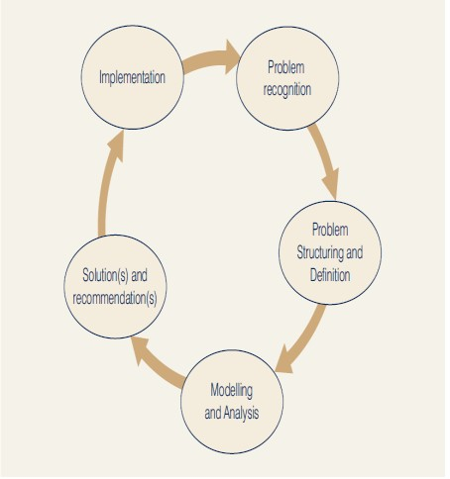 | 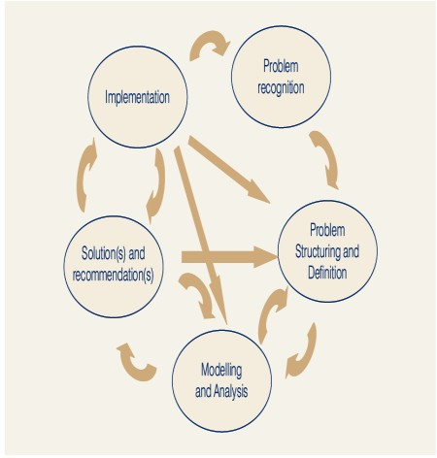
Figure 2: The OR Approach  (Adapted from Anderson et al, 2009, p. 9) | Figure 3: A revised OR approach  (Adapted from Anderson et al, 2009, p.12)

Anderson et al (2012) suggested that “For problems important enough to justify the time and effort of careful analysis, the problem-solving process involves seven steps (p.3)”. They are:

Step 1 : Identify and define the problem
Step 2 : Determine the set of alternative solution Step 3 : Determine the criterion
Step 4 : Evaluate the alternatives Step 5 : Choose an alternative Step 6 : Implement the decision Step 7 : Evaluate the results”

Thus, the decision making and problem solving model was proposed and presented in Figure 4. They explained that problem solving is closely related to decision making, the first 5 steps were decision making processes, by including the last two steps (Step 6 : Implement the decision & Step 7: Evaluate the results) which were to determine whether a satisfactory solution had been obtained, it then was a problem solving process.

Inspired by these findings, in this study, it is attempted through the investigation of the cognitive processes of the business degree students solving the DS problems, a set of algorithm and pattern strategy could be deduced, hence to help DS learners to enhance their problem solving skills.

In the next section, the methodology on data collection is discussed.

Decision Making
Implement the Decision
Define the Problem
Identify the Alternatives
Determine the criteria
Evaluate the Alternatives
Choose an Alternative
Decision

Figure 4: The relationship between problem solving and decision making
Problem Solving
Evaluate the Results
(Adopted from Anderson et al, 2012, p.5)

Methodology

To study the cognitive processes of students successfully solved the DS problems, a qualitative approach with a focus on phenomenography was adopted. A group of 42 willing business degree students were selected. They were in their second and third year of studies from six different institutes of higher learning in Malaysia, with age ranging from 19 to 25 years old. This group was selected because they are soon to graduate and embark for employment. The development of their logical and systematic problem solving skills is important during their formal education, as they are the future decision makers who will shape our society.

Data was collected individually and in four steps. Firstly, a 5-minute video on “think aloud” technique was introduced to the student. He/she was then asked to clarify and confirmed if he/she understood the meaning of “think-aloud” method. If not, further explanation would be carried out. Secondly, the student was then interviewed with the structured questions to find out the his/her simple bio data and academic background as well as their degree of exposure to the DS problems. Thirdly, student was given a DS problems (Exhibit 1) with a brief introduction on the problem However, students were ensured that he/she had the freedom to use whatever method(s) deemed suitable to solve the problem. Fourthly, once the student had completed solving the problem, based on his/her works, in retrospect, he/she was interviewed with semi-structured questions. Students were required to use the “think aloud” method during the problem solving session. The entire problem solving

session was video- and audio-recorded and time was also recorded accordingly. By combining the researcher‟s observation, field notes, students‟ works and verbatim, data were collected for analysis.

To classify the successful solvers and unsuccessful solvers, a marking scheme was developed and validated by two experts. Following a general rule of thumb of practice in the institutes of higher learning in Malaysia, above or equal to 40% of the total score is considered a Pass while below 40% is considered otherwise. All 84 written scripts were marked according to the marking scheme and results were validated by two experts.

The findings of the successful solvers will be discussed in the next section.
Exhibit 1: Sample of A Selected DS Problem
A company is involved in the production of two items (X and Y). The
resources needed to produce X and Y are twofold: namely, machine time for automatic processing and craftsman time for hand finishing. The table below gives the number of minutes required for each item:
The company has 40 hours of machine time available in the next working
week but only 35 hours of craftsman time. Machine time is costed at RM10 per hour worked and craftsman time is costed at RM2 per hour worked. Both machine and craftsman idle times incur no costs. The revenue received for each item produced (all production is sold) is RM20 for X and RM30 for
Y. The company has specific contract to produce 10 items of X per week for a particular customer.
Determine how much the company should produce per week.

(Source : adopted and adapted from Beasley (2004), Management Science Study Guide)

 |  | Machine time | Craftsman time
Item | X | 13 | 20
 | Y | 19 | 29

Results and Analysis

A random sample of 14 students‟ results for the Q1 (Table 1) were further analyzed by SPSS version 16 based on the frequency test, The frequency Table 2 shows that out of the 14 selected cases, there was 71.4% consistency between marker 1 and marker 2. This indicated little discrepancy in the marking of the Q1 DS problem.

Table 1: Summary Results of Two Markers on the DS Problem
Item No. | Script No. | 1st Marker | 2nd Marker | Variation

1 | HSP003 | 19 | 19 | 0
2 | HSP006 | 20 | 19 | 1
3 | HCG009 | 2 | 2 | 0
4 | HCG012 | 0 | 0 | 0
5 | HTR015 | 17.5 | 18 | -0.5
6 | HTR018 | 1 | 1 | 0
7 | HTR021 | 12.5 | 14.5 | -2
8 | HTR024 | 3 | 3 | 0
9 | UCW027 | 18 | 18 | 0
10 | USB030 | 7 | 6 | 1
11 | USB033 | 0 | 0 | 0
12 | UTY036 | 6 | 6 | 0
13 | UTY039 | 1 | 1 | 0
14 | UTY042 | 0 | 0 | 0

Table 2: Difference Between Marker 1 and Marker 2 for Q1 DS Problem

 |  | Frequency | Percent | Valid Percent | Cumulative Percent
Valid | -2 | 1 | 7.1 | 7.1 | 7.1
 | -0.5 | 1 | 7.1 | 7.1 | 14.3
 | 0 | 10 | 71.4 | 71.4 | 85.7
 | 1 | 2 | 14.3 | 14.3 | 100.0
 | Total | 14 | 100.0 | 100.0

The difference of marks from marker 1 and marker 2 was also supported by the Spearman‟s Rho Coefficient, which is a nonparametric measure of statistical dependence between two markers. It assesses how well the relationship between two markers using a monotonic function. Table 3 shows the results generated from the SPSS version 16 programme.

Table 3: Pearson Correlations Coefficient and Spearman’s Rho Coefficient to compare marks awarded by Marker 1
and Marker 2 for Q1 DS problem.
 | Marker 1 & Marker 2
Pearson | .997*
Spearman‟s rho | .997*
*significant level at the p < 0.01.

Although the sample size is less than 30 (n = 14), the result of Spearman‟s rho coefficient of 0.997 is supported by the Pearson‟s correlation coefficient (0.997). Both coefficients showed a similar value and this implied that both marks from marker 1 and marker 2 had a monotonic relationship.

To explore the cognitive processes of the successful students in solving the DS problem, the transcripts from students‟ verbatim, researcher‟s field notes and observation, and retrospection from interview were triangulated. The solution path and strategy were then derived.

The results show that there were 33% (or 14) the successful solvers (SS). Out of these 14 students, 86% (or 12) adopted a graphical approach, but with 50% (or 6) of them able to arrive at the correct answer without mistake. The other 50% (or 6) commited minor mistakes and not able to obtain the final answer correctly. The graphical method was the most popular approach adopted by these SS. That is, firstly, setting the mathematical model by identifying the objective, followed by constructing the structural constraints, and then the non-negative inequalities. Secondly, drawing a 2- dimentional diagram to represent the constraints and a feasible area was then identified. Finally, the optimum solution was identified from the diagram. It was noted that there was one common phenomenon - successful solvers (SS) seemed to follow a particular set of algorithm i.e., the behaviour of retrospection was revealed if they demonstrated after they had overlooked the key information (the different unit of time scale in the problem) in their first attempt to solve the problem.

Following Exhibit 2a and 2b show the example of the successful solver‟s solution path and strategy adopted.

Exhibit 2a : A Successful Solver‟s Solution Path in Solving the DS Problem
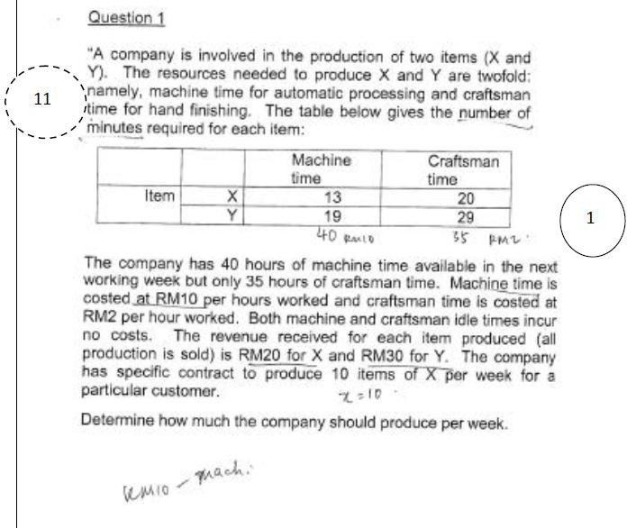 | 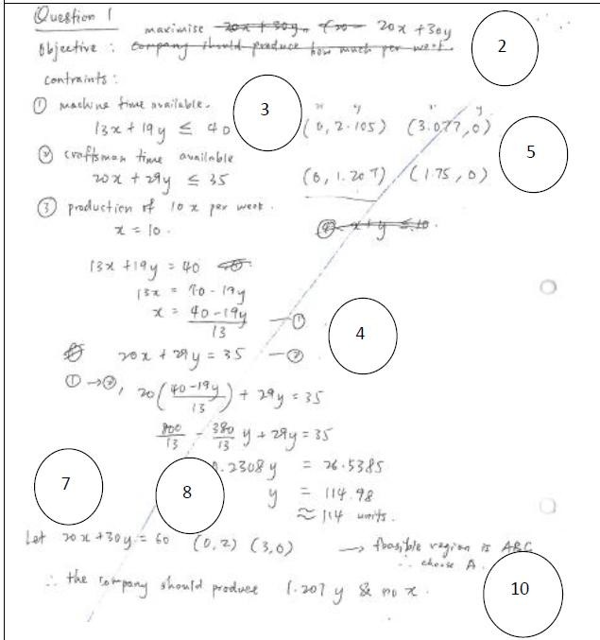

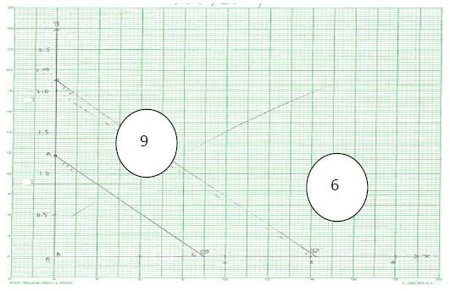 | 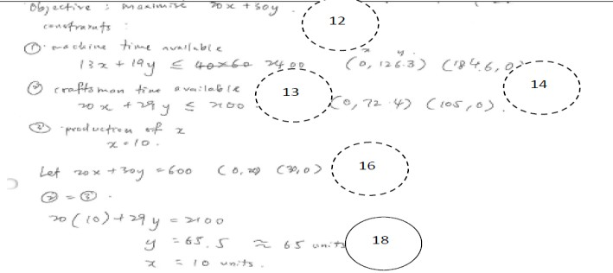
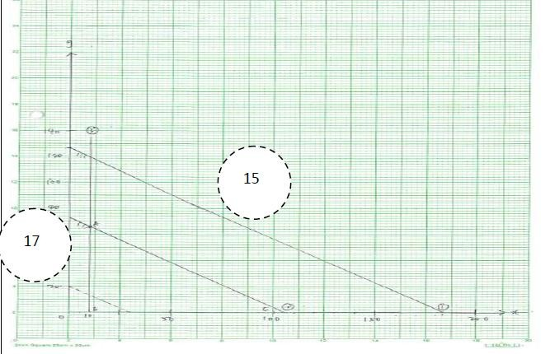 | 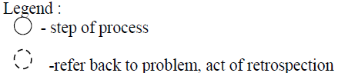

Exhibit 2b: Description of the Solution Path of a Successful Solver in Solving the DS Problem
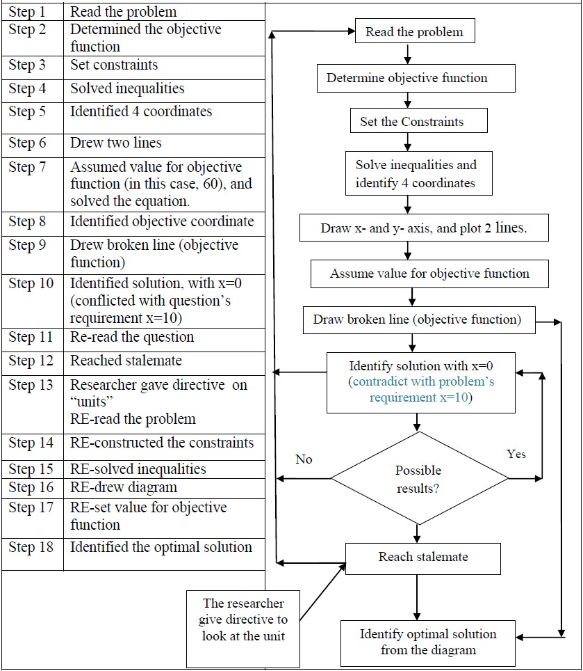

Exhibit 2a & 2b shows that the SS attempted the problem by setting the objective function, followed by constructing the constraint functions (inequalities). SS subsequently solved inequalities and obtained four coordinates, SS then plotted two lines on the graph paper accordingly. After that, SS assumed a value (of 60) for the objective function and solved the objective function to obtain another two solution points. SS was about to identify the optimal solution, however, it was found that the value of x was zero which contradicted with the question‟s requirement (x=10). SS then retrospected to the problem and tried to identify the mistake(s) made. Unfortunately, SS reached a stalemate. The researcher then prompted a hint to her to look at the unit of timescale. SS suddenly realised the mistake and crossed out the work done previously and re-started the processes on a new paper. SS re-determined the objective function and constraints, re-solved the inequalities and drew lines accordingly. Finally, SS was able to identify the optimal solution from the diagram.

The problem solving processes of SS can be summarised as shown in Exhibit 2c.

Exhibit 2c : The problem solving processes of SS in Solving the DS problem
Read the problem →Determine the criterion → Determine the set of alternatives → Evaluate the alternatives →Choose the alternative → Evaluate the results →RE- determine the objective function →RE- determine the set of alternatives → RE- evaluate the alternatives → RE-choose the alternative →Implement the selected alternative →Evaluate the results.

Regardless of what approach/methods the SS used, it was also noted that the problem solving processes of all the successful solvers generally resembled Anderson et al‟s (2012) 7-step problem solving process closely. Solvers demonstrated the behaviour of retrospection to varied extent. Some had longer steps and some had shorter steps. The difference was due to the retrospection at different solution points when individual successful solver encountered anomaly. It depended on which solution point where the anomaly was found during the problem solving session. In another word, if the problem solver introspected his/her workings at the end of the solution point (i.e. reviewed the recommended solution), and if he/she found any error, then he/she would have to re-solve the problem from the beginning. Thus, the problem solving process would be much longer compared to one that found an error in the middle of the process. This is reflected that Anderson et al‟s (2012) decision making/problem solving model has discounted the factor that the problem solver might introspect at any solution point during the course of solving the DS problem. Retrospection might be revealed whenever solvers sensed the situation which may end in a stalemate in the solution path.

Recommendation and Conclusion

It was noted that when problem solvers approached the DS problem, their cognitive processes were found to be following several discrete steps, the solution paths were not in a linearity and retrospection would happen whenever they encountered anomaly. Besides, problem solvers tended to draw upon their prior knowledge which played a very important role in determining the success rate of problem solving. In another word, problem solvers tended to retrieve some form of “formula” (refer to “stored information” in students‟ language) which was stored in their memories to solve the problem accordingly. This is supported by many studies (Clinton & Hokanson, 2012; Hong, 2013 and Wynder, 2007) that relevant knowledge helps develop creativity in solving similar problems. According to IPT, information stored in the memory might be lost, this helps to explain why some participants could not retrieve their stored information. And once they failed to retrieve their stored information, they encountered anomaly, they then gave up and stopped the problem solving process.

From the findings of this study, although the sample size may not big enough to generalize it in a wider context, it was noted that retrospection was a common behavior of solvers when they dealt with complex problem, they frequently demonstrated this behavior and to varied extent.

References

Albert, L. (1996). Seven-grade students' mathematical thought processes. 8th International Congress on Mathematics Education. Seville, Spain: July 14-21.

Al-Hudhaif, S. A. (1998). A visual interactive goal programming-based decision support system: An empirical assessment. (Order No. NQ31098, The University of Western Ontario (Canada)). ProQuest Dissertations and Theses, 181. Retrieved from http://search.proquest.com/docview/304482132?accountid=38738.(30448213).

Anderson, D. R, Sweeney, D. J., William, T. A., Camm, J. D., & Martin, R. K., (2012). An introduction to Management Science : quantitative approaches to decision making. Mason: South-Western Cengage Learning.

Anderson, D. R, Sweeney, D. J., William, T. A. & Wisniewski, M. (2009). An Introduction to Management Science: Quantitative Approaches to Decision Making. Cengage Learning EMEA, London.

Bernadette, B.C., Elizabeth, R.R., Linda, S.B. & Roger, L.D. (1994). Metacognition and problem solving: A process-oriented approach. Journal of Experimental Psychology: Learning, Memory and Cognition, 21(1), 205-223.

Cai, J. (1994). A protocol-anlaytic study of metacognition in mathematical problem solving. Mathematics Education Research Journal, 6 (2), 166-183.

Carpenter, P., Just, M.A., Shell, P. (1990). What one intelligence test measures, a theoretical account of the processing in the Raven Progressive Matrices Test. Psychological Review, 97(3), 404-431.

Clinton, G., & Hokanson, B. (2011). Creativity in the training and practice of instructional. Education Technology Research Development , 60, 111–130. doi 10.1007/s11423-011-9216-3

Ellis, H., & Hunt, R. (1993). Fundamentals of Cognitive Psychology. McGraw Hill.

Hong, F. T. (2013). The role of pattern recognition in creative problem solving: A case study in search of new mathematics for biology. Progress in Biophysics & Molecular Biology , 113 (1), 181-215.

Huitt, W.G. (1992). Problem Solving and Decision Making: Consideration of Individual Differences using the Myers-Briggs Type Indicator. Journal of Psychological Type, 24, 33-44.

Jakel, F., & Schreiber, C. (2013). Introspection in problem solving. Journal of Problem Solving , 6 (1), 20-33.

Kadafar, H. (2012). Cognitive model of problem solving. New/Yeni Symposium Journal, 195-206.

Lee, S.E. (2002). Cognitive and megacognitive processes in solving geometric problems. (Doctoral thesis). Available from the University of Malaya Digital Theses database.

Newell, A., & Simon, H. (1972). Human problem solving. NJ: Prentice Hall: Englewood Cliffs.

Ninth Malaysia Plan 2006-2010. The Economic Planning Unit, Prime Minister's Department Malaysia. Retrived from
http://www.epu.gov.my/en/ninth-malaysia-plan-2006-2010

Ohlsson, S. (2012). The problems with problems olving : Re-flections on the rise, curren status, and possible future of a cognitive research paradigm. Journal of Problem Solving, 5(1), 101-128.

Ormrod, J. E. (1999). Human learning . Upper Saddle River, NJ: Merrill.

Polya, G. (1954). Mathematics and plausible reasoning (vol. I, Induction and analogy in Mathematics and vol. II, Patterns and plausible inference), Princeton.

Rosenhead, J., & Mingers, J. (2001). Rational analysis for a problematic world revisited: Problem structuring methods for complexity, uncertainty and conflict. John Wiley.

Schoenfeld, A. H. (1992). Learning to think mathematically: Problem solving, metacognition, and sense making in mathematics. Handbook of Research on Mathematics Teaching and Learning, 334-370.

Wallas, G. (1926). The art of thought. NY, USA: Harcourt Brace.

Wang, Y., & Chiew, V. (2010). On the cognitive process of human problem solving. In N. Zhong, J. Liu and Y. Yao (Eds), Cognitive Systems Research, Journal of Science Direct, 11 (1), 81–92.

Wang, Y., Wang, Y., Patel, S., & Patel, D. (2006). A layered reference model of the brain (LRMB). IEEE Transactions on Systems, Man, and Cybernetics (C), 36(2), 124–133.

Wilson, L. B., & Clark, R. G. (1988). Comparative programming language.
Wokingham, UK: Addison-Wesley Publishing Co.

Wynder, M. (2007). The interaction between domain-relevant knowledge and control system design on creativity. Australian Journal of Management , 32 (1), 135- 152.

