Engaging Entrepreneurial Etiquette:
Driven by a Theory of Planned Behaviour

Pang Kim Kwong
School of Management and Business, Manipal International University
No 1, Persiaran Miu. 71800 Nilai, Negeri Sembilan, Malaysia
kimkwong.pang@miu.edu.my

Dr. Gomathi Shamuganathan
Marketing Department, Taylor's Business School, Taylor's University College
Subang Jaya, Selangor, Malaysia
shgomathi@yahoo.com

Abstract
Research Objective: The aim of this study is to analyze the entrepreneurial etiquette (EE) intention, behavior, and employer engagement with a group of Hospitality firms in Kuala Lumpur.
Methodology: Based on the three elements of behavior; attitude, subjective norms and perceived behavioral control, derived from a Theory of Planned Behavior. The empirical analysis is focused on the testing of the strength of these predictors toward customer satisfaction. In addition, 376 entrepreneurs from the industry were surveyed using questionnaires. Exploratory Factor Analysis (EFA) is described as orderly simplification of interrelated measures.It is a multivariate examination on the causal effect of entrepreneurial etiquette intention to customer satisfaction.
Scope of investigation/Findings: The main limitation of this research is the exposures of the respondents only to the Hospitality Industry in Kuala Lumpur. The study refers to business relational activities only. The Theory of Planned Behavior Model is applied. EFA has justified that a method of determining an appropriate, justified sample size in which the aims are estimating a population value, evaluating selected feasibility issues, assessing the adequacy of instrumentation and calculating estimates for use in planning a real study. The pre-analysis of data hygiene can be employed to avoid frustrations resulting after an EFA investigation. Data have to be screened as the factor analysis builds upon correlations. Such screening includes inspection for multivariate outliers, non-normal distributions, and linear vicariate relationships between variables. The results were positive. Thus, Confirmatory Factor Analysis on this study is suggested to proceed.
Introduction
Entrepreneurial Etiquette (EE) is a basic and necessary skill for working people of every level. EE demonstrates professionalism, promotes confidence and shows you care about yourself, your companionship, your customers and your workplace. “Etiquette” has originally been from an old French word meaning “a ticket”(DuPont, 1998).

A Chinese etiquette pioneer was Confucius (551–479 BC), who was a Chinese educator, editor, politician, and philosopher of Chinese History. The philosophy of Confucius highlighted personal and governmental integrity, rightness of social relationships, justice and genuine (Riegel, 1986).The etiquette uses in interpersonal interaction is conventional procedures. It is for the demonstrating of personalities, attitudes and relationships that including politeness, manners and protocols. Etiquette glimpses from the academic point of opinion; it is an art, style, intellectual coaching and emotional intelligence. From the industrial point of view, it is essentials to consumer relationship marketing, loyalty, satisfaction, image, and wealth creation.

Today, etiquette is founded on treating everyone with the same level of kindness and consideration, and it consists mostly of common sense (McCormick, 2010). His indication is worth to know some principles about how to act in certain occasions. This makes life more comfortable and gain self-confidence in social functions. The quantitative research conducted by Nga and Shamuganathan (2010) clearly stated that social entrepreneurship is the process of pursuing innovative solutions to societal problems. More specifically, social entrepreneurs adopt a charge to produce and sustain social value. Throughout the development and evolution of human's long history, the relationships between people in all categories are founded on carefully prescribed forms of conduct. It is included virtually every facet of the behaviors and culture. It is vitally important to such a degree that learning and following proper etiquette is one of the major aspects of life. The perceived EE is suggested to be driven by the Theory of Planned behavior towards customer satisfaction. Thus, perceived EE synchronizes behavioral intentions and behavior in the business arena.

The Underlying Theory

The theory of planned behavior was proposed by Ajzen (1985). It was initialed and evolved by Fishbein and Ajzen (1975) from the Theory of Reasoned Action. It is a rational and logical human action that used to predict and understand human nature. The Theory of Planned Behavior (Ajzen, 1988, 1991) recommends an example about how human action is piloted. It forecasts the event of a definite behavior stipulated that the behavior is intentional. The model is portrayed in Figure 1 and represents the three variables which the theory recommends will foresee the intention to accomplish a behavior.

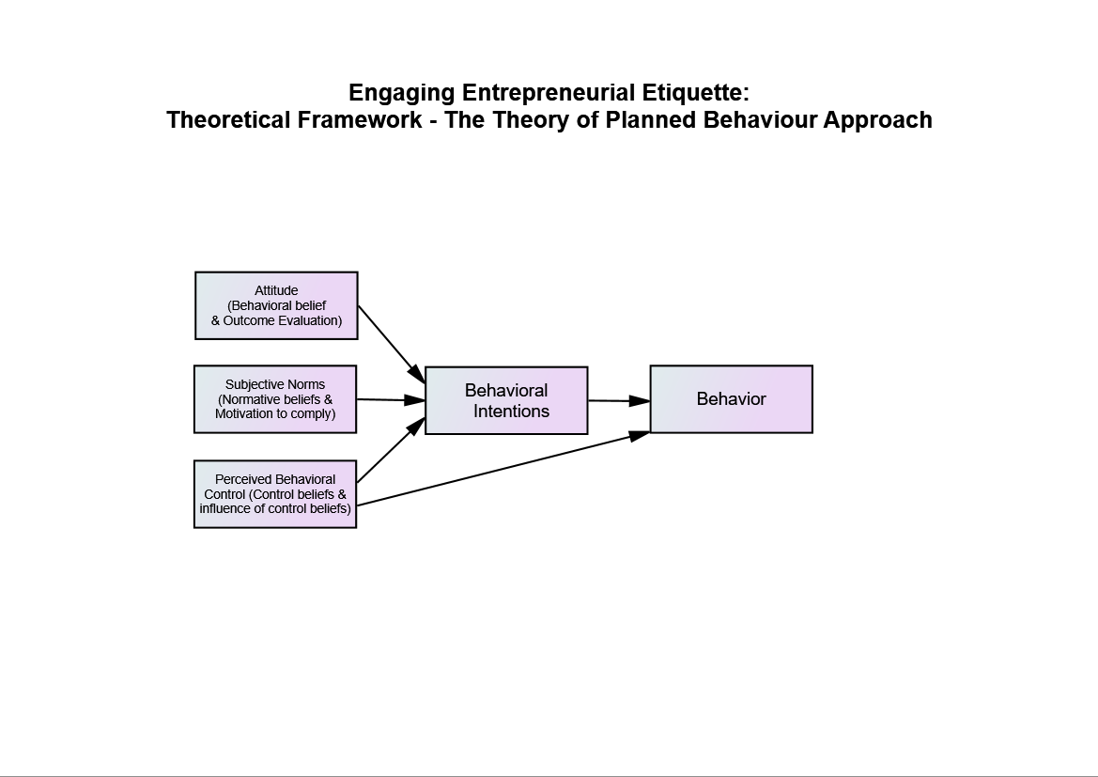
Figure 1: Theoretical Framework – The Theory of Planned Behavior
How the Theory of Planned Behavior Works
Theory of Planned Behavior is to foreshadow the intention of a person to do something (Figure 1). Such typology behavioral indicates three elements. The “attitude” is to indicate whether the person is in favor of acting it. The “subjective norm” represents the sense of feeling upon social pressure to do such behavior. Lastly, is the “perceived behavioral control”, it shows whether the person has the cognitive sense in control of the action performed. The Theory of Planned behavior is practical in constructing strategies to assist entrepreneur to embrace etiquette behaviors and to help entrepreneurs raise their perception of entrepreneurship guidelines.
- Behavior Element
In an empirical study, mediations are deliberate to change the behavior of entrepreneurs. The focus behavior should be defined cautiously in terms of its Target, Action, Context and Time. For instance, ponder the behavior, ‘treating customer a business lunch’. Here the target is the customer, the action is the dining, and the context is the entrepreneurial etiquette, and the time is (implicitly) during the lunch time. This guide is about the relevance of the TPB to specific behaviors. It is likely to use the model to explore further common behaviors; nonetheless it is important to spot the ‘principle of compatibility’ (Fishbein, 1967).
- Intention Element
Even though there is not an absolute link between behavioral intention and actual behavior, intention can be used as a proximity measure of behavior. This observation was one of the most important contributions of the TPB model in comparison with previous models of the attitude-behavior relationship. Thus, the variables in this model can be used to determine the effectiveness of implementation interventions, even if there is not a readily available measure of actual behavior.
- Attitude Element
Attitude with respect to the behavior is a person’s complete appraisal of the behavior. It is expected to have two parts which work jointly trusts about significances of the behavior and the tallying positive or negative judgment about each these features of the behavior.
- Subjective Norms Element
Subjective norms are a person’s own guess of the social pressure to execute or not execute the target behavior. Subjective norms are expected to have two elements which work in interaction: beliefs about how other people, who may be in certain way significant to the individual, would be fond of them to behave (normative beliefs), and the positive or negative judgment about each belief (outcome evaluations).
Perceived Behavioral Control
Perceived behavioral control is the extent to which individual sensesare able to ratify the behavior. It has two facets; how much a person has control over the behavior, and how confident a person feels about being able to perform or not perform the behavior. It is governed by control beliefs about the power of both situational and internal factors to prevent or enable the acting out of the behavior.
Statement of the Problems
A structural relationship between TPB and customer satisfaction transformation has not received considerate attention from the past researchers. Although, it is testified that the EE has brought an impressive customer relationship marketing that integrates marketable values as well as an important factor in relationship building, social interaction and attitudes impacts business success (Turner & Kleiner, 2001; Glick & Sally, 2008; Schaab & Kate, 2008; Sinlao & Jamison, 2012; Okoro, 2012; Pang, 2013). However, the empirical evidence for the etiquette-customer satisfaction correlation is still unsure. Thus, this work proposes to investigate the strength of coefficient correlation between EE and customer satisfaction, along with attitude, subjective norms, perceived behavioural control, and behavioural intentions.
Objective of the Study
The aim of this survey is to analyze the entrepreneurial etiquette implication and employer engagement to a group of Hospitality firms in Kuala Lumpur. The strength of these predictors, including EE, attitude, subjective norms, perceived behavioral control and behavioral intentions toward customer satisfaction is still unsure. TPB, principles of strategy and consumer behavior are applied to determine the correlation of this model. Specifically, it is a multivariate examination to find out the causal effect of EE to customer satisfaction.
Research Questions
In general, the objective of this study is to broaden the TPB concepts, including the conceptual business model of EE - customer satisfaction, to support its purpose in the Hospitality Industry in Kuala Lumpur. By studying the behavioral intentions, it is projected to explain and predict how entrepreneurs embrace etiquette professionalism. Especially, this research aims to response the following inquiries:
1. Does the behavioral model, such as the TPB and an extension of it, apply to the population of study in Malaysia?
2. What behaviors, intentions, and etiquette do entrepreneurs of the Hospitality Industry in Kuala Lumpur have towards customer satisfaction?
3. How these beliefs, grouped together with engagement, social interaction, and motivation, liaise with attitude, subjective norms, and perceived behavioral control in the contact of the Hospitality industry in Kuala Lumpur?
4. How do attitudes, subjective norms, and perceived behavioral control, influence the intention of entrepreneurs of the Hospitality industry in Kuala Lumpur?
5. Does the hierarchy model of Ajzen allow the entrepreneurial etiquette mediate the relationship between behavioral intentions and customer satisfaction?

A conceptual framework is drawn based on the research problem statement and research objective. Research framework is exhibited in the figure 2 below.

Research framework
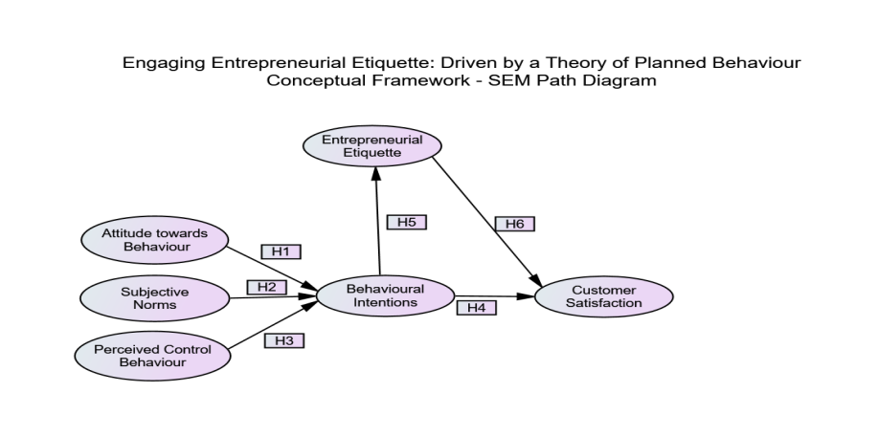
Figure 2: Conceptual Framework of Entrepreneurial Etiquette- Customer Satisfaction Model

Delimitations of the Study
This study is delimited the following aspects:
- All subjects were SMEs entrepreneurs, and entrepreneurs who work for the firms as senior managers, from the hotels, restaurants, and recreational clubs and tourist agents in Kuala Lumpur, Malaysia.
- The study refers to business relational activities only.
- The Theory of Planned Behavior Model is applied, but the Theory of Reasoned Action will not be taken in consideration. .
Significance of the Study
- Positive Perception and Productive
Perception is the decision processes that consumer investigate, selects, and read the messages received and made a sensible decision. Application of EE performs at the right time, place and person; promotes sales and increase entrepreneurial productivities. It is to build and maintain successful marketing relationships. EE is the motivator that drives the consumer to develop a persistent purchasing behavior. It is the expression processes that convincing enough to lead the consumer to trust in the entrepreneurial service quality and its noble image (Kotler et al, 2010).

- Promotes Total Quality Management (TQM)
Strategically, it is to suggest practicing professional EE will help to ensure, occupational environment is positive and productive. Ooi et al. (2008) emphasized that, the significance of TQM both theoretically and practically, were highlighted as the prime element in the success and survival of manufacturing as well as servicing industry.
- Entrepreneurial Development
The study penetrates insight of the marketing environment. According to Kotler (2008), the marketing environment includes the actors and forces outside marketing which affect management’s ability to build and maintain successful relationships with target customers.
- Reduce Post Purchase Dissonance
It is important to reduce post purchase dissonance of the customer. There are four cases of customer buying behavior. Based on the studies from Kotler et al (2010) and, Yusniza and Nor Khalidah (2012) the processes are, complex buying behavior, dissonance-reducing buying behavior, habitual buying behavior, and variety-seeking buying behavior.
Literature Review
Introduction
In the last two decades, a huge number of studies have been carried out in order to resolve factors that control the engagement of entrepreneurial etiquette (Erbe, 1996, Kennedy, 1999, Porterfield, 1999, Cardon, 2005, Lo, 2007, Mitchell, 2008). However, as was mentioned, merely a slight percentage of these studies have been committed to the engagement of entrepreneurial etiquette in the Hospitality Industry. Unlike from other industries, Hospitality, leisure and tourism firms have unique interpersonal relationship needs and different etiquette behavioral patterns (Langford, 2005, Fox, 2008, Rigout, 2008). In order to acquire more insights about engagement issues in the industry, the subsequent literature review surveys significant research that is paying attention to appeal entrepreneurial etiquette.
Background Information on Entrepreneurial Etiquette
Traditionally, etiquette quality evolved from common sense and respect for others. Etiquette is a code of behavior that delineates expectations for social behavior, according to contemporary conventional norms within a society, social class, or group. According to Gaier (1968), Sebastian Brandt was among the first advocates of good manners. In Brabdt’s 1494 work, a book called StultiferaNavis or Ship of Fools, a hilarious collection of woodcuts showing numerous breaches of the professional manners of the 15th century. Later, Wolffe (1997) identified Victorian England became obsessed with fine etiquette, and one of the greatest marketing efforts in etiquette was the Staffordshire craze of the 19th century.
The French word etiquette, literally signifying a tag or label, first appeared in English around 1750s. It devised and posted with rules for people to follow. The origin of today’s etiquette began in the French royal courts in the 16th and 17th centuries. In those days, people were more serious and strict on manners. The first known etiquette book was written in 2400 B.C. by Ptahotep (Grimal, 1992). In America, the first recordings etiquette was made in George Washington Rules of Civility. In the year 1922, Emily Post has written “Etiquette in Society, in Business, in Politic and at Home” (Post, Post & Post, 2011). Today, Peggy, the great granddaughter of Emily Post has continued to work on etiquette study. Her book is titled " Etiquette Advantage Business: Personal Skills for Professional Success," she branched out into her web of modern rules of good behavior. Also has expanded beyond the field of social etiquette. It is used as a tactic to become more successful in their company and in the business world.
DeMente, (2005) found that the Chinese word for etiquette, Li (礼), which originally meant "to sacrifice," refers to the fact that following legally sanctioned etiquette required extraordinary sacrifices, not to mention detailed knowledge of hundreds of correct forms of behavior. Etiquette came to be equated not only with learning in general, but with culture and morality even nationality and nationalism. The Chinese eventually came to believe that their behavior was the only correct etiquette in the universe, that all who did not follow the same meticulous rules of conduct need to change. Of course, the rules of etiquette in China today are no longer enforced by harsh feudal sanctions and they have been considerably relaxed, but they remain very important. There are still formalities, particularly in business and formal situations that are ingrained in the behavior of the Chinese.
Satisfaction Essentials
For the objective of this research, previous studies have been prearranged in three different streams varying on the category of entrepreneurial etiquette reviewed. The first stream groups together studies that have investigated the factors that influence attitude which comprises of behavioral beliefs and outcome evaluation. The second stream is related to subjective norms. It consists of normative beliefs and motivation to comply against etiquette behavior. Lastly, it is focused on the perceived behavioral control over control beliefs and influence of control beliefs on behavioral intentions and behavior.
The first two, individual attitude and customer relationship management systems, are selected as part of these literature reviews due to their relationship with etiquette. It appears natural to think that a predictor of etiquette behavioral should be an entrepreneur who already has adopted and applied such interrelationship tactic. Thus, findings regarding the predictors of these factors may be helpful in studying the postulation of etiquette behavior.
Similarly, the study of customer satisfaction in this review is essential because customer satisfaction is related to etiquette (manners, attire, punctuality, courtesy, protocol, etc.). Consequently, insights on the factors that predict the behavior of customer satisfaction can help to understand the factors that influence the engagement of the entrepreneurial etiquette behavior. For instance, it has been noted by a variety of researchers (Anderson, Fornell & Lehman, 1994; Taylor, and Baker, 1994) that customer satisfaction is one of the most essential elements of entrepreneurial etiquette, hence in securing the long-term profitability of any organization. Preceding marketing researches have suggested that customer satisfaction is impacted by the quality of an organization's products and services. However, an analysis done by Warren (2011) indicated that core product quality holds a weak causal influence over customer satisfaction, team identification, and service quality. Additionally, it was found that team identification was only a causal predictor of customer satisfaction and service quality evaluations in one model test.
Sowinski (2007) has inspected the associations between management behavior, service climate, customer satisfaction and financial performance. His result indicated for the support of the relationship between management behavior and service climate, and service climate and customer satisfaction. In the key findings of Back (2001) indicated that customer satisfaction is positively related to social and ideal social image congruence. Furthermore, outcomes provided evidence of a positive association between customer satisfaction and attitudinal brand loyalty. It was also found that customer satisfaction was positively associated with behavioral brand loyalty when mediated by attitudinal brand loyalty.
Research by Li (2002) that availability of service, responsiveness of service, reliability of service, completeness of service, and professionalism of service were identified as the five significant factors affecting customer satisfaction in parcel delivery service. The research concluded that all the five factors were positively correlated with overall customer satisfaction with respect to all customers. In addition, the reliability of the service was ranked as the most important among the five factors. Alonso (2000) justified that customer satisfaction and customer royalty is strongly correlated. His view was later supported by Kim (2010), who has provided updated findings to relate these two elements in marketing research. Employee engagement role plays an important factor to examine internal and external service factors that affect the relationship between employee-customer satisfactions (Chen, 2008).
The arguments testified from the above reviews, explicitly and implicitly envisaged that customer satisfaction derives from the entrepreneurial etiquette behavior.
Literature Review on TPB
There are conceptual and methodological uncertainties neighbouring the thought of perceived behavioural control. Ajzen (2002) clarified that perceived control over the performance of a behavior, although consisted of detachable components, mirror beliefs about self-efficacy and about controllability - can yet be deemed a unitary latent variable in a hierarchical factor model. It is further debated that there is an unnecessary correspondence between self-efficacy and internal control factors, or between controllability and external control factors. Self-efficacy and controllability can reveal internal as well as external aspects and the limit to which they replicate one or the other is an empirical matter. Lastly, a case is made that the dealings of perceived behavioural control need to combine self-efficacy in addition to controllability objects that are prudently chosen to guarantee excessive internal uniformity.
Research Methodology
Katsicas (2009) has proposed that when proper to a subject of methodology, such processes make a constructive generic framework and may thus be worn down into sub-processes, combined, or their sequence changed. So, the layout of the framework is as under.A detailed outline of how an investigation will take place (Figure 3). A research design will typically include how data is to be collected, what instruments will be employed, how the instruments will be used and the intended tools for analyzing data collected (Kervin, 1992; Chua, 2012).

Figure 3: Methodological Framework in Hypothetical-deductive Approach
Sample and Procedure
The research focuses only on the population of the Hospitality Industry in Kuala Lumpur Malaysia. Small and Medium Enterprises (SMEs) are to be taken into account in this research. It is noted from the SMEs Corporation of Malaysia that commenced from the 1st day of January, 2014, the definition of SMEs is based on two criteria; that is, it refers to the total sales turnover/revenue of a business in a given year; or refers to the number of full-time employees of a business. Generally SMEs in Malaysia are defined as follows: Manufacturing sector: Sales turnover not exceeding RM50 million OR full-time employees not exceeding 200. Services and other sectors: Sales turnover not exceeding RM20 million OR full-time employees not exceeding 75.
According to a report from the Department of Statistic, there are 645 136 numbers of SME firms in Malaysia. The number of SMEs in W.P. Kuala Lumpur is 84 261. Based on the research, 99.4% of the firms are from Service Sector and Hospitality Industry accounted for 20.70%. Therefore, Service Sector consists of 83 755 firms (84 261 X 99.4 %). Hence, the population of the Hospitality Industry in W.P. Kuala Lumpur is accounted for 17 337 (83 775 X 20.70%) firms. Based on the Table, the sample size is 376(Krejcie & Morgan, 1970).
Technique of Data Collection
The empirical research aims at attitude, subjective norms, perceived behavioral control, behavioral intention and customer satisfaction of a hospitality organization. The respondents are the entrepreneurs or the General Managers of the organizations. The organizations targeted are hotels, restaurants, recreational resorts and travel agents.
Based on the calculation, a sample of 376 respondents will be randomly selected from the targeted population. A set of relevant questionnaire will be designed based on the query of research questions. It will be in hard and soft copies. Computer hard and software, stationeries and communication medium are required to run the survey. There are 1000 sets of questionnaires will be handed or mailed or emailed to the respondents.
Functions of Exploratory Factor Analysis (EFA)
Child (1990) described exploratory factor analysis as orderly simplification of interrelated measures. According to Hair et al. (2010), EFA is used to:

i. Prior to confirming any real relationship specified, define a possible relationship between factors in the most general manner.
ii. Any insignificant items for parsimony are excluded.
iii. Serve as a data reduction technique.
iv. Involve a process of item selection and evaluation.

EFA has been applied to explore the possible underlying factor structure of the theory of planned behavior model without preconceived on the outcome. EFA based on the responses of the participant determent the factor structure of the model. Thus, the number of constructs and the underlying factor structure are identified.
Preliminary Analysis
The output of the correlation matrix is used to check the pattern of correlations. First, look for any significance values in any variable; they should be more values that are less than 0.05. Secondly, scan the correlation coefficients that are greater than 0.9. If both are found, a problem of singularity is found and have to be eliminated the variables causing the problem. All questions in the pilot test correlate fairly well and none of the correlation coefficients are especially large.

KMO and Bartlett's Test
Kaiser-Meyer-Olkin Measure of Sampling Adequacy. |  | .651
Bartlett's Test of Sphericity | Approx. Chi-Square | 942.730
 | df | 190
 | Sig. | .000

The Kaiser-Meyer-Olkin measures of sampling adequacy and Bartlett’s test of sphericity. KMO measures value from 0 and 1. Those values closer to 1 are better; a value of 0.6 is a suggested minimum. Bartlett’s Test of Sphericity is to test the null hypothesis that the correlation matrix is an identity matrix. The value.000 shows its significant (Sig.). Look at the table above, these tests have provided a minimum standard, i.e. KMO.651 and Sig. .000.
Eigen values are variances of the factors. The first factor is, always has the highest value (5.002) and hence accounted for the most variance. The cumulative % under initial eigen values accounted for by the current and all preceding factors. The sixth row shows a value of 68.163; this means that the first six factors together accounted for 68.163% of the total variance.
Conclusion and Discussion
The aim of the EFA is to illustrate a method of determining an appropriate, justified the sample size in which the aims are estimating a population value, evaluating selected feasibility issues, assessing the adequacy of instrumentation and calculating estimates for use in planning a real study. The pre-analysis of data hygiene can be employed to avoid frustrations resulting after an EFA investigation. Data have to be screed as the factor analysis builds upon correlations. Such screening includes inspection for multivariate outliers, non-normal distributions, and linear bivariate relationships between variables (Pedhazur & Schmelkin, 1991; Stevens, 1996; Kline, 1998; Forman, 2001; Tabachnick & Fidell, 2001).

References
Ajzen, I. (1985). From intention to actions: A theory of planned behavior. Action-control: From cognitive to behavior (pp. 11-39). Heidelberg, Germany: Springer
Ajzen, I. (1988). Attitude, personality, and behavior. Chicago, IL:Dorsey
Ajzen, I. (1991). The theory of planned behavior. Organizational Behavior and Human Decision Processes. Vol. 50 No. 2 pp. 179-211
Ajzen, I. (2002). Perceived Behavioral Control, Self-Efficacy, Locus of Control, and the Theory of Planned Behavior. Journal of Applied Social Psychology, 2002, 32, 4, pp. 665-683.
Alonso, S. (2000). The antecedents and consequences of customer loyalty: The roles of customer satisfaction and consumer trust-commitment. The Humanities and Social Sciences Collection. Retrieved fromhttp://search.proquest.com/docview/304681262?accountid=38738
Anderson, E.W., Fomell, C., & Lehmann, D. R. (1994). Customer satisfaction, market share, and profitability: Findings from Sweden. Journal of Marketing, 58, 53-66
Back, K. (2001). The effects of image congruence on customer satisfaction and brand loyalty in the lodging. The Humanities and Social Sciences Collection. Retrieved from http://search.proquest.com/docview/304718655?accountid=38738
Cardon, P. W. (2005). A qualitative study of the role of face in chinese business culture: Implications for american businesspersons. The Humanities and Social Sciences Collection. Retrieved from http://search.proquest.com/docview/305398056?accountid=146023
Chen, T. (2008). The examination of factors that affect the relationship between employee-customer satisfaction in recreational sports/fitness clubs in Taiwan. The Humanities and Social Sciences Collection. Retrieved from http://search.proquest.com/docview/304825690?accountid=38738
Child, D. (1990). The essentials of factor analysis, 2ndedn. London: Cassel Educational Limited
Chua, Y.P. (2012). Mastering research statistics. Shah Alam: McGraw-Hill Education

DeMente, B.L. (2005). Chinese etiquette and ethics in business. 2nd New York: McGraw Hill
DuPont, M.K. (1998). Business etiquette and professionalism: your guide to career success, Menlo Park, CA: Cengage Learning
Economic and Census, (2011). Department of Statistics, Malaysia. Available at: http://www.ecommercemilo.com/2013/12/malaysia-sme-statistics-ecommerce-readiness.html#.VIGLZ7UcRLM [Accessed on: 5thDecember, 2014]
Erbe, C. S. (1996). Enhancing the benefits of cooperative education through structured learning experiences. The Humanities and Social Sciences Collection. Retrieved from http://search.proquest.com/docview/304241656?accountid=38738 [Accessed on: 28/03/2015]
Fishbein, M. (1967). Reading in attitude theory and measurement. New York, NY: Wiley
Fishbein, M. and Ajzen, I. (1975). Belife, Attitude, Intention, and behavior: An Introduction to Theory and research. Reading, MA: Addison- Wesley
Forman, D.R. (2001). Elements to Consider in Planning the use of Factor Analysis. Southern Online Journal of Nursing Research, 5, Vol. 2
Fox, S. (2008). Business Etiquette For Dummies. 2ndedn. Hoboken, NJ, USA: For Dummies. Retrieved from http://www.ebrary.com
Gaier, U. (1968). Sebastian Brant’s narrenschiff and the humanists, PMLA, German, (May, 1968) 83: 266-270
Glick, J. And Sally, G. (2008). Marketer’s Role VS Business Etiquette. CPA Practice Management Forum. 4.4 (Apr 2008): 19-20, US: Riverwoods
Grimal, N. (1992). A history of ancient Egypt, London: Blackwell Publishing, p. 79
Hair, J.F.Jr., Black, W.C., Babin, J.B. & Anderson, R.E. (2010). Multivariate data analysis: A global perspective. 7thedn. USA: Pearson Prentice Hall
Katsicas, S. K. (2009). Computer and Information Security Handbook. Morgan Kaufmann Publications. Elsevier Inc. p. 605. ISBN 978-0-12-374354-1
Kennedy, V. G. (1999). Ethic and etiquette at work. The Humanities and Social Sciences Collection. Retrieved from http://search.proquest.com/docview/230947385?accountid=146023
Kervin, J.B. (1992). Methods for business research. New York: Harper Collin Publisher
Kim, M. R. (2010). The importance of customer satisfaction and delight on loyalty in the tourism and hospitality industry.The Humanities and Social Sciences Collection. Retrieved from http://search.proquest.com/docview/815811243?accountid=38738
Kline, R.B. (1998). Principles and practice of structural equation modeling. New York: Guiford Press
Kotler, P., Armstrong, G., Ang, S.H., Leong, S.M., Tan, C.T. &Yau, O.H.M. (2010). Principle of marketing- consumer markets and consumer buyer behavior: A global perspective. Available at: www.ln.edu.hk/mkt/staff/l2peng/bus205/Chapter05. [Accessed on: 25/10/2014]
Kotler, P., Armstrong, G., Wong, V. & Saunders, T. (2008). Principles of marketing. 5th edn. Harlow: Pearson Education
Krejcie, R.V., & Morgan, D.W., (1970). Determining sample size for research activities. Educational and Psychological Measurement
Langford, B. Y. (2005). Etiquette edge : The unspoken rules for business success. Saranac Lake, NY, USA: AMACOM Books. Retrieved from http://www.ebrary.com
Li, B. (2002). A study of critical factors of customer satisfaction in parcel delivery service. The Humanities and Social Sciences Collection. Retrieved from http://search.proquest.com/docview/305523847?accountid=38738
Lo, K. D. (2007). An Empirical Investigation of Emic Differences between American Networking and Chinese Quanxi and a Process Model of Building Relationships for Cross-Cultural Business Interactions. The Humanities and Social Sciences Collection. Retrieved from http://search.proquest.com/docview/304847203?accountid=38738 [Accessed on: 27/03/2015]
McCormick, L.C. (2010). Minors in procession of bad manners. Retrieved online from http://library.thinkquest.org/2993/history.htm [Accessed on: 06/06/2014]
Mitchell, G. W. (2008). Essential soft skills for success in the twenty-first century workforce as perceived by Alabama business/marketing educators. The Humanities and Social Sciences Collection. Retrieved from http://search.proquest.com/docview/304185329?accountid=146023
Nga, J. &Shamuganathan, G. (2009) The influence of personality traits and demographic factors in social entrepreneurship, accepted for publication in Journal of Business Ethics, Vol. 95, Issue 2, pp. 259-282. DOI 10.1007/s10551-009-0358-8
Okoro, E.A. (2012). Cross-Culture Etiquette and Communication in Global Business: Toward a Strategic Framework for Managing Corporate Expansion. International Journal of Business and Management, Vol. 7, No. 16. ISSN 1833-385
Ooi, K.B., Arumugam, V., Teh, P.I. & Chong, A.Y.L. (2008). TQM Practices and its Associations with Production Workers. Industrial Management & Data Systems, vol. 108, No. 7, pp. 909-927
Pang, K.K. (2013). Business Etiquette Professionalism its Strategic Influence on Customer Relationship Marketing. Research Project,Master Dissertation (unpublished), Asia e University
Pedhazur, E. &Schmelkin, L. (1991). Measurement, design and analysis. Hilldale NJ: Erlbaum
Porterfield, S. Y. C. (1999). United States Fortune 500 Companies Human Resource Directors' Perceptions Regarding Competencies Required in the 21st Century of Entry-Level Business Employees with Four-Year Business Degrees. The Humanities and Social Sciences Collection. Retrieved from http://search.proquest.com/docview/304509780?accountid=38738 [Accessed on: 27/03/2015]
Post, P., Post , A. & Post, L. (2011). Emily Post's etiquette: manners of the world, 18thedn. NY: HarperCollins Publishers
Riegel, J.K. (1986). Poetry and the Legend of Confucius's Exile. Journal of the American Oriental Society106 (1). JSTOR 602359
Rigout, F. C. (2008). Unlikely meritocracy: Corporate responsibility and the ideological reconstruction of the brazilian business elite. The Humanities and Social Sciences Collection. Retrieved from http://search.proquest.com/docview/304697301?accountid=146023
Schaab, K. & Kate, C. (2008). Good Grooming: Etiquette and Beauty Guids Culture Segregation Post-World War II America. Ann Arbor: ProQuest, UMI Dissertations Publishing
Sinlao, and Jamison, J. (2012). Money Can’t Buy You Class: Culture Capital, Etiquette, and the White Wedding. University of California, US: ProQuest UMI Dissertation Publishing
Sowinski, D. R. (2007). The Moderating Effects of Climate Strength on the Leader-Climate-Customer-Satisfaction-Profitability. TheHumanities and Social Sciences Collection. Retrieved from http://search.proquest.com/docview/304851002?accountid=38738
Stevens, J. (1996). Applied multivariate statistics for the social science, 3rdedn Mahwah NJ: Erlbaum
Sureschchandar, G.S., Rajendran, C. and Anantharman, R.N. (2002), The Relationship between Service Quality and Customer Satisfaction – A Factor Specific approach. Journal of Service Marketing, Vol.16 No. 4. pp. 363-379
Tabachnick, B.G. &Fidell, L.S. (2001). Using multivariate statistics. 4thedn New York: Harper Collins
Taylor, S. A., & Baker, T. L. (1994). An Assessment of the Relationship between Service Quality and Customer Satisfaction in the Formation of Consumers’ Purchase Intentions. Journal of Retailing, 70 (2), 163-178
Turner, W and Kleiner, B.H. (2001). What Managers Must Know to Conduct Business in Brazil.Management Research News. Vol. 12 No. ¾
Warren, C. J. (2011). Understanding the Impact of Core Product Quality on Customer Satisfaction, Team Identification, and Service Quality.The Humanities and Social Sciences Collection. Retrieved from http://search.proquest.com/docview/898986111?accountid=38738
Wolffe, J. (1997). Religion in Victorian Britain: Culture and Empire. Volume V. Manchester University Press. pp. 129–30
Yusniza, K. &NorKhalidah, A. (2012). Marketing management. Shah Alam: Oxford University Press

