Brand Advocacy and Repurchase Intention of Malaysian Automotive Owners using SEM approach

Simon C.M. Kwong, DBA
Asia e University
simoncmkwong@gmail.com

Introduction
The automotive sector is a significant player in the country’s industrial development. It spurs technological development and stimulates inter-industry linkages. By virtue of its nature, it stimulates development in other industries such as plastics, steel, electronics, rubber, textiles, glass, and metals. This multiplier effect can be seen in more than 350 component manufacturers equipment suppliers, professional and financial services and research and training institutes, car dealership, repairs and auto parts retailing. This cascades into job creation for more than 250,000 people either directly or indirectly.
As a generator of growth and development, the industry is an important source of revenue for the government contributing overall more than 5% of the total revenue. It accounts for 65% of the government’s annual excise duty revenue and 30% of sales tax revenue which amounts to approximately RM 3.3 billion and nearly RM 2 billion respectively (http://proton.com.my). Given this significant contribution, it makes sense why the government should ensure that the industry is well protected and supported. Among ASEAN countries Malaysia is one that takes an overt intervention in the automotive sector as evident by the initiation of the national car project.

Table 1.02 2007-2011 Malaysian Total New Automobile Sales
 | 2007 |  | 2008 |  | 2009 |  | 2010 |  | 2011
Brand | Sales | Market  Share* | Sales | Market  Share* | Sales | Market  Share* | Sales | Market  Share* | Sales | Market  Share*
Perodua | 75,483 | 34.2 | 83,589 | 30.1 | 166,736 | na | 188,641 | 32.4 | 155,419 | 29.9
Proton | 46,955 | 21.3 | 72,957 | 26.2 | 148,031 | na | 157,274 | 27.0 | 151,577 | 25.2
Toyota | 36,572 | 16.6 | 53,129 | 19.1 | 81,784 | na | 89,666 | 15.4 | 51,291 | 8.6
Honda | 14,175 | 6.4 | 16,766 | 6.0 | 38,783 | na | 44,483 | 7.6 | na | na
Nissan | 8,336 | 3.8 | 14,925 | 5.0 | 25,957 | na | 30,374 | 5.2 | 12,204 | 2.0
Source: Malaysian Automotive Association,
2012 *market share < 5.0 are omitted from the table

With the introduction of ASEAN Free Trade Area (AFTA) in 2005 which led to a cut in duties on imported cars and the liberalization of the automobile sector, local car companies faced increasing competitions not only among cars within the same sector but also with imported cars. Thus with increasing competition from foreign companies, the market share of domestic automakers shrunk. PROTON, a heavily government-supported initiative was gravely affected in the competition with top global carmakers like Toyota, General Motors, Ford, BMW and Daimler Chrysler (http://www.autoindustry.co.uk/). Under AFTA, cars made by these foreign companies just need to have a local content of at least 40 percent to enjoy preferential import duties. These companies have already set up manufacturing plants in Thailand which has lower labor costs. Table 1.02 does not show a very promising picture for the local automobile industry based on the yearly sales since 2007 despite the huge initial investment provided by the Malaysian government. This paper tries to shed some light on the problem faced by the Malaysian Automotive Industry and the strategies that may help its survival going forward in the face of stiff competition.

Theoretical Framework
The study aims to uncover the problems faced by the local automotive industry, in particular the cause of declining sales. Why did automotive buyers choose one car over the other? Is it simply because it is cheaper, more prestigious, reliable and so on. What guide their behavior? What can we learn from their behavior? For this purpose we look to a few theories to set the theoretical framework – The Theory of Reasoned Action, the belief-attitude interaction model, the conceptualization of reasoned action and the relationship marketing theory.

The Underlying Theory of Reasoned Action (TRA)

In trying to understand consumer behavior – advocacy and repurchase intentions, we can look at the much-researched Theory of Reasoned Action (Ajzen and Fishbein, 1980; Fishbein and Ajzen, 1975) which explains that behavior is determined by the behavioral intention to produce that behavior (see Figure 2 . 01). There are two main factors that determine behavioral intentions, first, a personal or "attitudinal" factor and second,, a social or "normative" factor. B a s e d o n an expectancy-value formulation, the first factor (the person's attitude toward a specific behavior) is proposed to be a function of the salient (behavioral) beliefs about t h e perceived consequences of performing the behavior and the person's (outcome) evaluation of these consequences. The second factor, subjective norms, consist of an actor’s perceptions of what important specific referent individuals or groups think he or she should do. The subjective norms a r e a function of the p e r s o n ’ s (normative) beliefs about what each referent thinks he or she should do and the motivation to comply with these referents. It is thus expected t h a t the relative importance of the attitudinal and normative factor s in determining intention will vary according to the behavior, the situation, and individual differences of the actor (Ajzen and Fishbein,1980).

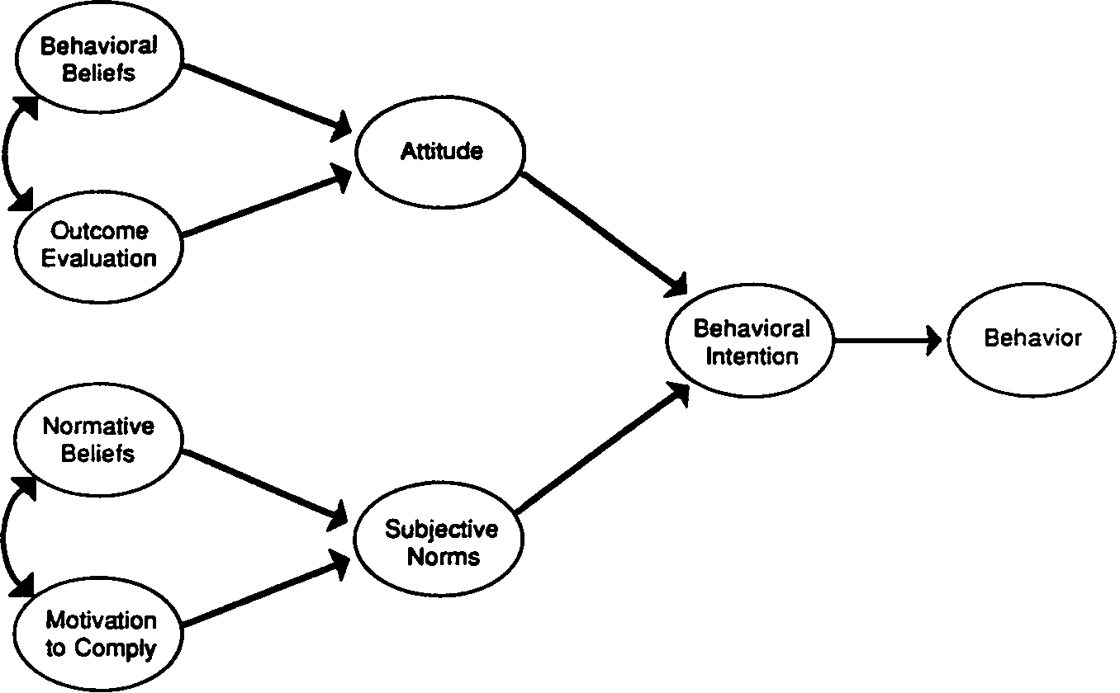

Figure 2.01 The Basic Theory of Reasoned Action

The Belief-Attitude-Intention Model

To investigate the relationship between respondents’ perceived brand perceptions of value, quality, equity, satisfaction, commitment, advocacy and repurchase intentions, this study makes use of Fishbein and Ajzen’s (1967) model of beliefs-attitudes-behavioral intentions (Figure 2.01) to explain the relationships between consumers’ perceptions of value, quality, equity (beliefs) satisfaction, commitment (attitude) towards the brand, and r e purchase intentions (behavioral intentions). In this model, beliefs are the primary blocks. A person forms certain beliefs about a brand based on several ways such as direct observation or information received from outside sources or by way of various inference processes. These beliefs are then linked or associated with certain attributes. They eventually become the informational base that forms attitudes, intentions and behaviors towards certain objects, persons or events or relationships. Attitude is thus a learned predisposition that determines how a person responds to objects, persons, events and relationships in a consistently favorable or unfavorable way.
Behavioral intention on the other hand, refers to a person’s subjective probability that they will perform some “specific” behavior towards something. According to Fishbein and Ajzen’s (1967) a person’s intentions, are a function of certain beliefs which influence attitude towards performing a given behavior and his evaluation of the consequences. It is assumed that the more favorable a person’s attitude toward a brand, the higher the probability that he would have intentions to act positively. Conversely, the less favorable attitude would lead to negative behaviors.
Based on this, Fishbein and Ajzen (1967) state that behavioral intentions serve as an intervening variable between one’s attitudinal and obvious behavior. In other words, the best predictor of a given behavior should be the person’s intention to engage in that behavior. Therefore it follows that to predict a specific behavior such as their repurchase intention, it is necessary to measure the person’s attitude and intentions toward performing that behavior. Thus, if one can predict behavioral intentions, one can also predict actual behavior (Hemdi, 2005; Newberry, Klemz and Boshoff, 2003).
Conceptualization of Reasoned Action

According to Warshaw and Davis ( 1985) purchase intention is defined as the degree to which a person has formulated conscious plans to perform or not to perform some specified future behavior. Positive belief is related to a h igh level of intention to purchase while negative belief is related to consumers with low level of purchase intention (Shim and Drake, 1990). Purchase intention is the consumers’ tendency to act positively toward an object and is generally measured in terms of intention to buy (Kim, 2003).
Purchase intention is an important factor for an organization that has to make strategic decisions concerning both new and existing products (Morwitz, Steckel and Gupta, 2006). Numerous studies have been performed to explain the determinants of purchase intentions and their findings are of particular interest to the marketers involved in making decisions on whether a concept merits further development (Li,
2004) or whether a new product merits launch in which geographic markets and segments the product should be launched (Sewall, 1978; Silk and Urban, 1978; Urban and Hauser, 1993) as well as in pretesting and evaluating proposed promotions for both new and existing products (Morwitz et al., 2006). Besides this, the concept has been extensively used in forecasting future demand (Armstrong, Morwitz and Kumar,
2000). These forecasts are useful inputs to make decisions on production, sales staff recruitment and pricing.

In academic research, purchase intentions have been used as proxy measures for purchase behavior (Ajzen and Fishbein, 1980; Akaah, Korgaonkar and Lund, 1995; Akhter and Durvasula, 1991; Schlosser, 2003). Interestingly, in a meta-analysis study on how intentions are conducted by Morwitz et al., (2006) found that intentions are significantly better predictors of purchase behavior for existing products and for durable than for non-durable products over a short term period. These results are significant because in practice, intentions are often used to predict sales for new non-durable products (Gruber, 1970; Haley and Case, 1979; Jamieson and Bass, 1989; Pringle, Wilson and Brody, 1982).

The Relationship Marketing Theory

The new directional push towards relationship marketing has been described as a "fundamental reshaping of the field" (Webster, 1992, p. 1) while others see this as a genuine paradigm shift (Kotler 1991; Parvatiyar, Sheth, and Whittington 1992). Relationship marketing is a concept that encompasses relational contracting (MacNeil 1980), relational marketing (Dwyer, Schurr, and Oh 1987), working partnerships (Anderson and Narus 1990), symbiotic marketing (Varadarajan and Rajaratnam, 1986), strategic alliances (Day 1990), co-marketing alliances (Bucklin and Sengupta 1993), and internal marketing (Arndt 1983; Berry and Parasuraman 1991). It is part of the developing "network paradigm," where global competition occurs between networks of firms (Thorelli 1986, p.47). Paradoxically, the relationship between these networks are held together by norms of sharing and commitment based on trust (Achrol, 1991, p.78, 89). According to strategist, McKinsey and Co. (Bleeke and Ernst 1993, p.1), "…the days of flat-out, predatory competition are over.... In place of predation, ma ny m u ltination a l companies are learning that they must collaborate to compete.'' Business ethicists also stress that competition requires cooperation (Solomon 1992, p. 26):

“However competitive a particular industry may be, it always rests on a foundation of shared interests and mutually agreed-upon rules of conduct, and the competition takes place not in a jungle but in a society that it presumably both serves and depends upon. Business life, unlike life in the mythological jungle, is first of all fundamentally cooperative. It is only with the bounds of mutually shared concerns that competition is possible. And quite the contrary to the 'everyone for himself metaphor, business almost always involves large cooperative and mutually trusting groups, not only corporations themselves but networks of suppliers, service people, customers, and investors.”

The adopted research framework below in Figure 2.04 has encapsulated the essence of the traits of relationship marketing and at the same time has the “attitudinal” and “behavioral” attributes that were required for this study.

Research Structural Framework and Hypotheses of the study

Figure 2.04 Research Framework
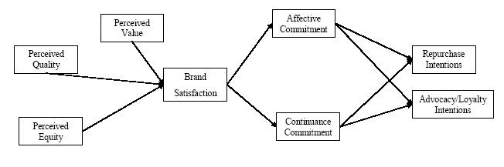
Perceived value upon customer satisfaction

Researchers in the past have tried to integrate customer perceived value and customer satisfaction together (Heskett et al., 1990; Storbacka et al., 1994; Liljander, and Strandvik, 1995; Woodruff, 1997). But few has been able to demonstrate empirical evidences of the causal links between perceived value and satisfaction (Crosby and Stephens, 1987; Patterson and Spreng, 1997; Andreassen and Lindestad, 1998; Cronin et al., 2000; McDougall and Levesque, 2000). The proposed relationship of perceived brand value upon customer satisfaction is supported by value disconfirmation experience. When a single purchase of a product or service is made, the customer expects to receive a benefit greater than the cost, that is, the customer expects to receive value from the purchase. If anything were to happen after the purchase was made that unexpectedly reduced or increased the cost incurred or benefit received, the “perceived brand value” would be altered accordingly. Then, the customer become “less” or “more” satisfied, which in turn influenced subsequent customer value expectations, repurchase behavior and the overall customer satisfaction experience (Woodruff, 1997; Voss et al., 1998; Carr, 1990; Lanza, 2008). Thus it is clear that customer’s perception of overall service value positively impacts upon customer overall service satisfaction. In a relationship with the services supplier, customers select options and create value to them (i.e. added value to them) and so increase their product or service satisfaction (Carr, 1990; Normann and Ramirez, 1993; Ravald and Gronroos, 1996; Gronroos, 1997; Rosen and Surprenant, 1998; Woodruff, 1997). Hence the hypothesis proposed is hypothesized as:

H1. Perceived Brand Value positively influences Customer Satisfaction.

Perceived equity upon customer satisfaction

Several studies found customer perceived brand equity influences customer satisfaction, following a purchase transaction (Oliver and DeSarbo, 1988; Oliver and Swan, 1989; Erevelles and Leavitt, 1992). Customer overall satisfaction is therefore often understood by market researchers to be a consequent variable of perceived brand equity and other processes (Swan and Oliver, 1985; Takala and Uusitalo, 1996; Szymanski and Henard, 2001). This view is further supported by other studies where dissatisfied customers who successfully obtain redress (procedural, distributive and interactional justice) are likely to experience improved overall satisfaction with the service (Andreassen, 2000; de Ruyter and Wetzels, 2000; Tax et al, 1998; Boshoff and Leong, 1998; Bitner et al, 1990; Blodgett et al, 1995). Hence the hypothesis proposed is framed as:

H2. Perceived Brand Equity positively influences Customer Satisfaction.

Perceived quality upon customer satisfaction

The relationship of perceived quality to satisfaction at either the transaction-specific or global level of analysis is not universally agreed upon (Zahorik and Rust, 1992; Taylor and Baker, 1994; Parasuraman et al, 1994b). However, researchers had treated perceived quality as a relatively stable perception of the service which had influenced customers’ experiences satisfaction or dissatisfaction with specific instances of the service (Bejou et al, 1996; Athiyaman, 1997; Bolton and Drew, 1991a, b; Boulding et al, 1993). While there were other researchers that represented perceived quality as an antecedent, rather than a result of satisfaction (Fornell et al, 1996; Spreng and Mackay, 1996; Danaher and Gallagher, 1997; Wels-Lips et al, 1998; Woodside et al, 1989). Furthermore, some studies, upon examining the causal order between customer perceptions of overall service quality and customer satisfaction, found it difficult to establish that one empirically precedes the other (McAlexander et al, 1994; Taylor and Baker, 1994; Taylor and Cronin, 1994). Even where perceived quality is understood to be an antecedent to satisfaction, some researchers also had indicated that there could be diminishing satisfaction returns to an increase in the level of service quality provided (Anderson and Sullivan, 1993; Johnston, 1995; Caruana and Pitt, 1997; Woodruff, 1997; Mittal et al, 1998). It had also been argued that perceived quality may not be a significant determinant of customer service assessments when the service has high credence attributes (Powpaka, 1996). Powpaka (1996) tested and found that perceived quality did positively influence satisfaction. Thus the hypothesis proposed is being hypothesized as:
H3. Perceived Brand Quality positively influences Customer Satisfaction.

Customer Satisfaction upon Brand Affective Commitment

Customer satisfaction can influence attitudinal change (e.g. brands, services and supplier preferences) which in turn affects their repurchase intention (Innis, 1991; Oliver, 1980; Oliver and Bearden,
1985; Strauss and Neuhaus, 1997). A high level of satisfaction is likely to increase the probability that the
brand in question will be retained in the customer's consideration set and will increase the customer's preference and affection for the brand (Westbrook and Oliver, 1981). Thus the hypothesis proposed is hypothesized as:
H4. Customer Satisfaction positively influences Brand Affective commitment.

Customer Satisfaction upon Brand Continuance Commitment

Opportunity cost analysis suggests that customer satisfaction has a positive causal effect on the expected disadvantage or cost in switching service suppliers. That is, the higher the level of the customer's overall satisfaction with the service or brand, etc, the larger the opportunity cost or satisfaction foregone that the customer could be expected to incur in switching service suppliers. However, the positive relationship between satisfaction and continuance commitment may be confounded in the short term when companies adopt defensive marketing strategies which utilise switching costs as a means of retaining dissatisfied customers (Fornell, 1992). Though in the long-term, the ability of switching cost barriers to retain the patronage of dissatisfied customers is probably quite limited and short-sighted (Jones et al., 2000; Maute and Forrester, 1993). Hence the hypothesis proposed for this study is hypothesized as:

H5. Customer Satisfaction positively influences Brand Continuance Commitment.

Brand Affective Commitment upon Repurchase Intentions and Brand Advocacy

In the buyer-seller context, commitment has been treated as a key dependent variable between exchanging parties (Dwyer et al, 1987; Anderson and Weitz, 1992; Dwyer et al, 1992; Morgan and Hunt, 1994). Some involve only the psychological aspects of commitment while others argue for the inclusion of behavioral aspects as well. While many authors had suggested that commitment is essential in both the consumer and business context, it is essential to note that almost all published studies were done in the business-to-business market (Dwyer et al, 1987; Gundlach et al, 1995). However, much remains to be done in understanding commitment in the consumer market, especially for the Malaysian automotive market. Thus, the hypotheses proposed are hypothesized as follows:

H6 Brand affective commitment positively influences brand repurchase intentions.
H7 Brand affective commitment positively influences brand advocacy

Brand Continuance Commitment upon Brand Repurchase Intention and Brand Advocacy

Brand Advocacy and Brand Repurchase Intention represent the customer’s self-reported likelihood of engaging in further repurchase behavior (Seiders et al., 2005). It is revealing to consider customer intentions for increasing the level of demand for a firm’s products. In the research models investigated, committed customers are not just expected to maintain the business relationship, but are also expected to increase both the level and proportion of their purchasing activities over time (Grönroos, 2004). Besides the above mentioned characteristics, Lacey and Morgan (2009) argued that there was a relationship between committed customers and their willingness to repurchase the same brand or services again in future. It would certainly be useful to the Malaysian Automotive Industry for obtaining concrete evidence among the Malaysian automobile owners that advocacy and repurchase intentions are indeed influenced by continuance commitment. Thus, the hypotheses proposed are hypothesized as:
H8. Brand Continuance Commitment positively influences Repurchase Intention.
H9. Brand Continuance Commitment positively influences Brand Advocacy

Methodology
The unit of analysis in this research is the Malaysian automobile owners. Data was collected from various locations in Ipoh and the Klang Valley. Using purposive sampling the research managed to get 748 respondents who were prepared to submit their questionnaires out of a total of 2000 questionnaire distributed. This represented a return rate of just fewer than 40%. This research was conducted through self-administered questionnaires whereby the questionnaire consisted of the different brand constructs amalgamated into a complete sets of contiguous questions for effective comprehension. The questions focused on the independent variables of PBE (brand equity), PV (brand value), PQ (brand quality) as well as the dependent variables of AC (affective commitment), CC (continuance commitment), LI (advocacy) and RI (repurchase intention) with each having three items per brand construct with the only exception of BS (brand satisfaction) which had four items. All measures were adapted and modified from (Allen & Meyer, 1990; Chaudhuri & Holbrook, 2001; Putrevu & Lord, 1994; Zeithmal et al, 1996; Aaker & Keller,1992; Sweeney & Souter, 2001; Simonin & Ruth, 1998);Lanza (2008). The demographic variables asked were gender, race, age, income, years driven, engine capacity and number of car(s) owned. The data were keyed into SPSS version 20 software program and analyzed using AMOS version 20. Several statistical validity tests and analysis were conducted such as reliability test and composite reliability tests, validity test using confirmatory factor analysis (CFA) for construct validity, discriminant validity for multicollinearity treatment, descriptive analysis, correlation and structural equation modeling analysis using AMOS 20.0

Figure 1: Hypothesized Model
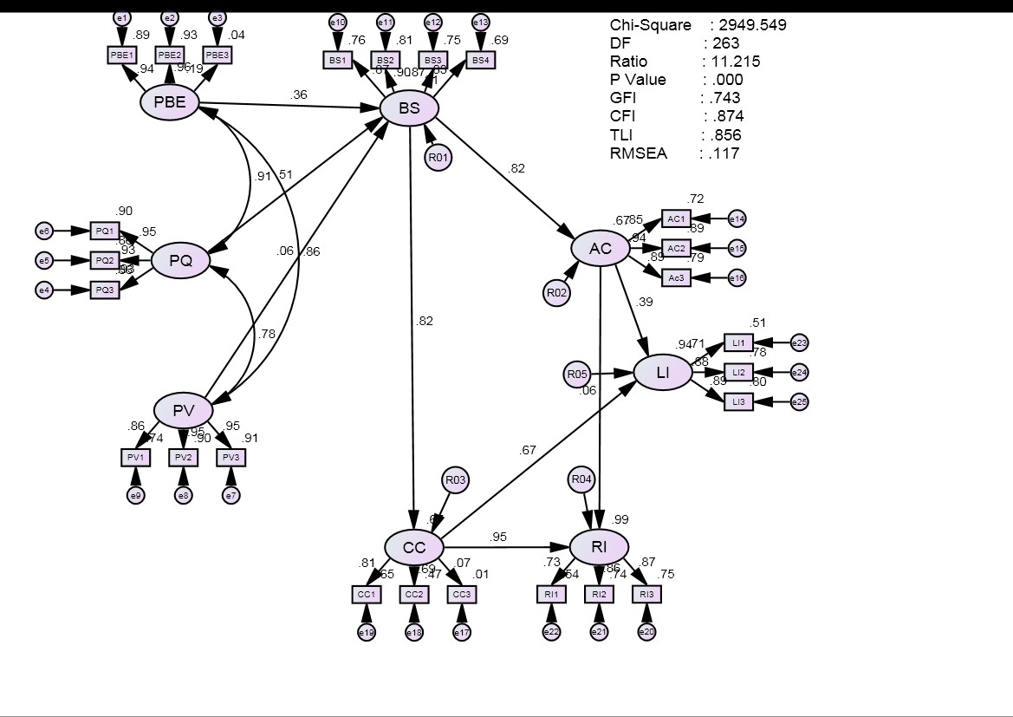

Findings:
Table 2: The profile of respondents (Proton, N=173; Perodua, N=299; Others, N=276)
Demographics  Gender | Proton |  | Perodua | Others
Male | 56.7 |  | 36.5 | 65.2
Female  Ethnicity | 35.8 |  | 63.5 | 34.8
Malay | 38.2 |  | 27.1 | 32.6
Chinese | 22 |  | 30.1 | 29.7
Indian | 10.4 |  | 15.1 | 11.6
Sarawakian | 11.6 |  | 9 | 9.1
Sabahan | 9.8 |  | 7.4 | 8.7
Others | 6.9 |  | 6.4 | 7.2
Age  <19 |  | 0 | 5 | 0
<29 |  | 8.17 | 22.8 | 5.8
<39 |  | 30.7 | 35.1 | 8
<49 |  | 58 | 20.4 | 26.8
<59 |  | 17.3 | 9.4 | 42
>60 |  | 15.7 | 6 | 15.2
Income
<3000 |  | 27.7 | 27.8 | 5.8
<5000 |  | 38.2 | 48.2 | 7.2
<7000 |  | 9.2 | 17.4 | 15.2
<9000 |  | 8.1 | 6.4 | 16.7
<11000 |  | 9.2 | 0.3 | 25.7
>11000 |  | 6.4 | 0 | 23.2
Engine capacity
<1.0k cc |  | 0 | 56 | 0
<1.3k cc |  | 35 | 35 | 0
<1.6k cc |  | 45 | 9.4 | 21
<1.8k cc |  | 8.7 | 0 | 32
<2.0k cc |  | 5.8 | 0 | 33
>2.0k cc |  | 5.7 | 0 | 12
As a driver
< 2yrs |  | 16.8 | 1 | 10.9
< 4yrs |  | 15 | 28.9 | 12.3
< 6yrs |  | 23.2 | 28.4 | 26.1
< 8yrs |  | 22.5 | 23.7 | 21.4
< 10yrs |  | 12.7 | 5 | 17.8
> 10yrs |  | 9.8 | 8 | 11.6
Auto owned
1 |  | 24.9 | 27.5 | 9.1
2 |  | 29 | 27.8 | 30.8
3 |  | 13.8 | 11 | 39.5
4 |  | 14.5 | 12 | 10.1
5 |  | 10.4 | 7 | 6.9
Others |  | 7.3 | 7 | 3.6

From the Table 2, it could be observed that for the Malaysian manufactured Proton, male ownership was at 56.7% whereas Perodua ownership was dominated by female at 63.5%. Similarly the ethnic composition of Malay for Malaysian model were at 37% and 27% respectively, while Chinese were at 22% and 30% respectively and Indian were at 10.4% and 15.1% respectively. From the monthly income statistics Malaysian auto owner having Malaysian made models were generally below the RM5k bracket and their ages were mainly below 49 years of age and usually had driven less than 10 years. The researcher believed that the above sample in terms of gender, ethnicity, income, age, cars owned and engine capacity produced moderately homogenous sample pool for this research.

Descriptive analysis of variables
Table 3: Descriptive statistics of variables No of
Variable Name | items | Cronbach's Alpha | Mean (Std Dev)
(PBE) Perceived Equity | 3 | 0.697 | 2.99 (+1.20)
(PQ) Perceived Quality | 3 | 0.899 | 3.15 (+1.04)
(PV) Perceived Value | 3 | 0.946 | 3.42 (+1.32)
(BS) Brand Satisfaction | 4 | 0.933 | 3.72 (+1.15)
(AC) Affective Commitment | 3 | 0.868 |  | 3.13 (+1.15)
(CC) Continuance Commitment | 3 | 0.762 |  | 2.87 (+1.21)
(RI) Repurchase Intention | 3 | 0.783 |  | 3.09 (+1.30)
(LI) Advocacy/Loyalty Intention | 3 | 0.855 |  | 3.12 (+1.35)
 | 25

From Table 3, it is observed that the Cronbach’s alpha before the confirmatory factor analysis was conducted were between 0.697 to 0.946. This indicated that the items in each construct collectively measured as a set the appropriate brand concept and the reliability of the measures used in this study can be considered as internally consistent (Sekaran, 2003).

Confirmatory Factor Analysis results
Table 4: Final Confirmatory Factor Analysis results of construct variables

Variable Code Attributes Factor Loadings
My overall satisfaction level with the brand that I own can best be described

Brand Satisfaction BS1
as: 0.761

(BS) BS2 I am pleased with the brand that I currently owned 0.806
Overall, the brand of automobile that I currently own had met my

BS3
expectations 0.755

BS4 If I had to do it over again, I would buy the same brand again 0.691

Affective Commitment AC1 I feel emotionally attached to the brand 0.717 (AC) AC2 I have a strong sense of identification with the brand 0.892
AC3 This brand has a great deal of personal meaning for me 0.788

Continuance Commitment CC1
(CC)
When the time comes to make a purchase it would be difficult for me to
switch 0.649

Advocacy/Loyalty Intention
(LI)

LI2 The likelihood that I would buy the same brand again is? 0.778
LI3 I would consider buying this brand before any other brand 0.796

Repurchase Intention
(RI) RI2 I would consider myself loyal to this brand 0.738
RI3 The likelihood that I will continue to be a loyal customer to this brand is: 0.753

Perceived Quality PQ1 What do you think of your quality of your brand? 0.902 (PQ) PQ2 How do you rate the performance of your brand? 0.857
PQ3 How do you feel about the reliability of your brand? 0.863

Perceived Value PV1 This brand is reasonably priced 0.741 (PV) PV2 This brand offers value for money 0.904
PV3 This brand is a good product for the price 0.911

Perceived Equity PBE1 I have a positive image of the brand 0.89 (PBE) PBE2 My experience with the brand had been very good 0.927

From the confirmatory factor analysis result in Table 4, it was observed that the factor loadings of all observed variables or items are high ranging from 0.649 to 0.911. This indicated that all the constructs conform to the construct validity test.

Composite Reliability and Discriminant Validity of the Constructs
Table 5: Composite reliability and variance extracted of variables

Variables

obs var | std loading | R2 | error var εj | Composite reliability | Variance Extracted
BS1  BS2  BS3 | 0.849  0.930  0.878 | 0.721  0.865  0.771 | 0.279  0.135  0.229 | 0.916 | 0.786
jml | 2.657 | 2.357 | 0.643
AC1  AC2  AC3 | 0.756  0.887  0.862 | 0.572  0.787  0.743 | 0.428  0.213  0.257 | 0.875 | 0.700
jml | 2.505 | 2.101 | 0.898
CC1  CC2  CC3 | 0.642  0.558  0.515 | 0.412  0.311  0.265 | 0.588  0.689  0.735 | 0.594 | 0.330
jml | 1.715 | 0.988 | 2.011
LI1  LI2  LI3 | 0.642  0.877  0.838 | 0.412 0.588  0.769 0.231  0.702 0.298 |  | 0.833 | 0.628
jml | 2.357 | 1.884 | 1.116
PBE1  PBE2 | 0.931  0.947 | 0.867  0.897 | 0.133  0.103 | 0.937 | 0.882
jml | 1.878 | 1.763 | 0.236
PQ2  PQ3 | 0.807  0.883 | 0.651  0.780 | 0.349  0.220 | 0.834 | 0.715
jml | 1.69 | 1.430 | 0.569
PV1  PV2  PV3 | 0.834  0.894  0.968 | 0.696  0.799  0.937 | 0.304  0.201  0.063 | 0.927 | 0.811
jml | 2.696 | 2.431 | 0.568

Table 5 shows the result of the calculated composite reliability and variance extracted to support composite reliability of each construct (with error consideration) and discriminant validity of constructs respectively (Nejatian et al, 2011; Ali and Sentosa, 2008). According to Fornell and Larcker (1981), average variance extracted (AVE) should be more than the correlation squared of the two constructs to support discriminant validity is supported or multicollinearity is absent.

Table 6: Correlation & Correlation Squared Matrix
Variable Name | BS | AC | CC | RI | LI | PQ | PV | PBE
BS - Brand Satisfaction  AC - Affective Commitment  CC - Continuance  Commitment  RI - Repurchase Intention  LI - Advocacy PQ - Quality PV - Value PBE - Equity | 1  .566** (.320)  .477** (.227)  .585** (.342)  .593** (.352)  .740** (.548)  .616** (.379)  .708** (.501) | 1  .555** (.308)  .509** (.259)  .641** (.411)  .617** (.381)  .495** (.245)  .570** (.325) | 1  .532** (.283)  .584** (.341)  .558** (.311)  .389** (.151)  .513** (.263) | 1  .615** (.378)  .673** (.453)  .510** (.260)  .605** (.366) | 1  .698** (.487)  .583** (.340)  .691** (.477) | 1  .601** (.361)  .750** (.562) | 1  .762** (.581) | 1
**. Correlation is significant at the 0.01 level (2-tailed), values in bracket indicate correlation squared.

Goodness of Fit Indices
Confirmatory factor analysis was conducted on the exogenous and endogenous variables of the measurement model. The two sets of CFA produced relatively good fit as indicated by the goodness of fit indicies such as CMIN/df ratio (<2); p-value (>.05); Goodness of Fit index (GFI) of >.95; and root mean square error of approximation (RMSEA) of value less than .08 (<.08). The measurement model has a good fit with the data on assessment criteria such as GFI, CFI, TLI, RMSEA (Nejatian et al, 2011; Bagozzi and Yi, 1988). Table 7 shows that the goodness of fit generated by the revised model is better compared to the hypothesized model. New path were also generated from perceived equity and quality to affective commitment as well as to continuance commitment.

Table 7: Goodness of fit analysis-comparison between hypothesized and re-specified model
(N=748)

Goodness-of-Fit Statistics for Hypothesized and Re-Specified Exogenous CFA model
Goodness-of-Fit Statistics |  | Desired value of goodness-of-Fit criteria | Hypothesized  Model | Re-specified  Model
Chi-squared | χ2 | p>0.05 | 285.332 (p<0.001) | 82.513 (p<0.001)
Degrees of Freedom | Df | >0.00 | 24 | 19
Chi-square/degree of  Freedom ratio | χ2/df | 2 to 5 | 11.889 | 4.343
Root mean square error of approximation | RMSEA | <0.08 | 0.121 | 0.067
Goodness-of-Fit index | GFI | >0.90 | 0.924 | 0.976
Comparative fit index | CFI | >0.90 | 0.967 | 0.992
Tucker-Lewis index | TLI | >0.90 | 0.951 | 0.985

Hypothesis Results:
Table 8 Path Coefficients for Malaysian automotive owners' as a single group (N=748)
Path | As a Group
 | Beta | C.R. | Sig. | H | Accepted
Perceived Brand Equity to Brand Satisfaction | 0.373 | 3.449 | 0.000 | 1 | Yes
Perceived Brand Quality to Brand Satisfaction | 0.420 | 4.612 | 0.000 | 2 | Yes
Perceived Brand Value to Brand Satisfaction | 0.046 | 0.750 | 0.453 | 3 | No
Brand Satisfaction to Brand Affective Commitment | 0.047 | 1.087 | 0.277 | 4 | No
Brand Satisfaction to Brand Continuance Commitment | -0.011 | -0.262 | 0.793 | 5 | No
Brand Affective Commitment to Brand Advocacy/loyalty Intentions | 0.268 | 6.935 | 0.000 | 6 | Yes
Brand Affective Commitment to Brand Repurchase Intentions | 0.161 | 3.662 | 0.000 | 7 | Yes
Brand Continuance Commitment to Advocacy/Loyalty Intentions | 0.787 | 17.123 | 0.000 | 8 | Yes
Brand Continuance Commitment to Brand Repurchase Intentions | 0.852 | 17.516 | 0.000 | 9 | Yes

Figure 2: The re-specified model
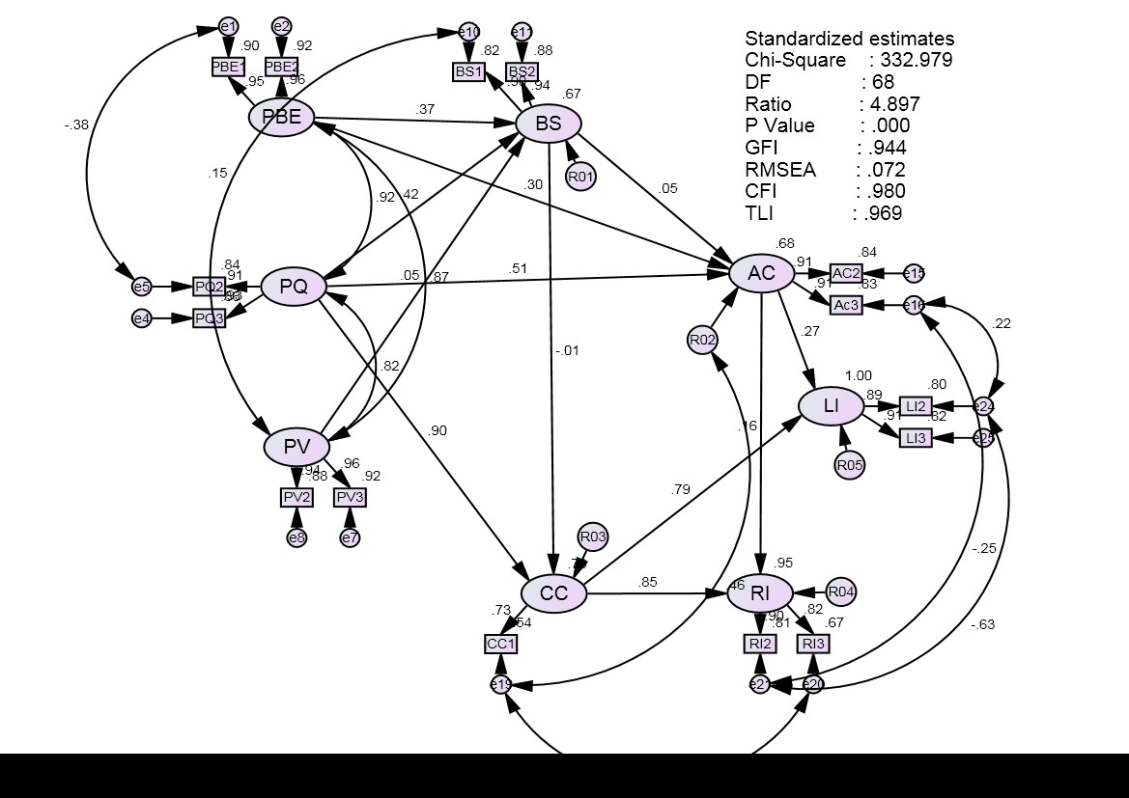

Figure 2 above depicts the structural path readings derived from the Structural Equation Modeling (SEM) analysis. The Goodness-of-Fit (GOF) of the structural model shows support according to the standard norms in structural equation GOF indices as presented in Table 7.

Discussion
The objective in this study was to relate the applicability of the TRA theory in the advocacy and repurchase intention of Malaysian automotive owners pertaining to their future purchases. Consequently, it was found that perceived brand perception of equity, value, affective and continuance commitment had significant influence in the advocacy and repurchase intentions of auto owners in their future auto purchases. These findings were similar with many past findings (Tolba, 2006; Aaker, 2004; Johnson et al, 2006; Keller, 2003; Fornell et al, 1996; Parasuraman et al, 1996). The findings also highlighted that there were no significant influence for value on satisfaction and satisfaction on affective & continuance commitment of the advocacy and repurchase intention of the auto owners.
The findings also found that Malaysian brand automotive owners were quite loyal to the local brand because the “switching cost” is a huge barrier. Due to such an advantage the Malaysian automotive industry should capitalize on this nationalistic sentiment among the existing customers though the product quality was left much to be desired. The Malaysian Automotive Industry should ensure that product attributes must meet basic quality standards in order to retain existing customers as well as attract new purchasers.

Conclusion and suggestions for future research
The Malaysian automotive industry has a high level of acceptance among the young population below the age of 40 with middle income of less than RM6k per month. The auto industry should try to focus on this segment of the market for their products. Nationalistic sentiments also play to the advantage of the local industry if their products met the basic level of quality and acceptance by the local buyers. Due to the “switching cost” for the imported models the local industry has the edge over their imported models. The Malaysian model suggested in this study could be useful for product and automotive sales research for the local automotive industry in Malaysia.

References

Aaker, D. A., (1991). “Managing Brand Equity: Capitalising on the Value of a Brand Name”, The Free Press, New York, NY.
Ajzen, L., and Fishbein, M., (1980), Understanding attitudes and predicting social behavior, Englewood Cliffs, NJ: Prentice Hall.
Anderson, J. C., and Narus, J. A., (1990). “A model of distributor firm and manufacturer firm working in partnership”. Journal of Marketing Vol. 54, No. 1, pp. 42-58.
Berry, L.L., and Parasuraman, A. (1991). Marketing Services. New York: The Free Press. Bucklin, Louis P. and Sanjit Sengupta (1993), "Organizing Successful Co-Marketing
Alliances," Journal of Marketing, 57 (April), 32-46.
Dwyer, F.R., Schurr, P.H., and Oh, S. (1987). “Developing Buyer-Seller Relationships,” Journal of
Marketing, 51(April): 11-27.
Hoyle, R. (Ed.) (1995), Structural Equation Modeling: Concepts, Ideas, and Applications. Sage
Publications, Thousand Oaks, CA.
Kline, R.B. (2011). Principles and practice of structural equation modelling (3rd ed.). New York: The
Guilford Press.
Kohli, C., and Thakor, M. (1997). “Branding consumer goods: insights from theory and practice,” Journal of Consumer Marketing, vol. 14, issue 3, pp. 206.
Nunnally, J.C. (1978). Psychometric Theory. New York, NY: McGraw-Hill.
Reichheld, F.F. (2003). “The one number you need to grow”. Harvard Business Review, 81(12), 10-
15.
Rosli, M. and Kari, F. (2008) “Malaysia’s national automotive policy and the performance of Proton’s foreign and local vendors”. Asia Pacific Business Review, Vol. 14, pp.103–118.
Rust, R.T. and R. L. Oliver (1994), Service Quality: New Directions in Theory and Practice, Sage
Publishers, Inc., London.
Sentosa, I., Nejatian, H., Piaralal, SK., and Faisal. A, (2011). Empirical Study of Internet Adoption among Small and Medium Enterpreneurs (SMEs) in Malaysia (A structural equation modelling approach). 2nd International Conference on Business and Economic Research (2nd ICBER 2011) Proceeding. (pg. 1067-1082).
Spreng, R.A., and Mackay, R.D., (1996). “An Empirical examination of a Model of Perceived Service
Quality and Satisfaction,” Journal of Retailing, vol.72, no.2 (1996):201-214.

