The Impact of Leadership Roles on Team Satisfaction, Team Effectiveness and Project Performance – A Study of Project Managers in Malaysia

Fung Han-Ping
Hewlett-Packard Malaysia

Shamala Ramasamy
UCSI University

Abstract: Many organizations today are deploying project teams to deliver various services or resolve different problems as they recognize the team performance is always exceeding the individual outputs combined. According to Project Management Institute (PMI) (2013), project manager’s leadership skills are deemed important as they contribute to achieving the project goals set by the stakeholders. However, there is a lack of study that examines whether a project manager’s leadership roles can improve team satisfaction, team effectiveness and project performance concurrently (Cohen & Bailey, 1997) or following a certain pattern of dependencies. In light of addressing these concerns, this study developed a research model based on research works conducted by Cohen and Bailey (1997), as well as by Yukl (2010) to empirically analyze how leadership roles influence team satisfaction, team effectiveness and project performance. Result showed that when a project manager demonstrates his or her leadership roles more frequently, the project team becomes more effective. Increase in team effectiveness leads to higher team satisfaction and improved project performance. Moreover, when the project team becomes more satisfied, it will also directly increase project performance. However, execution of the leadership roles by project manager will not directly influence the team satisfaction and project performance.

Keywords: Project Manager, Leadership Role, Project Team Satisfaction, Project Team Effectiveness, Project Performance.

1. Introduction
Project team is formed to provide various services or resolve different problems in many organizations. Typically, a project team comprises of a project manager and a group of team members in performing the work to achieve the project goals (Project Management Institute [PMI], 2013). The rationale of using project team is that team performance as a group always outpace individual outputs (Belbin, 1993).
In order to achieve project goals, the project manager needs to demonstrate his or her relevant leadership skills to guide the project team (PMI, 2013). According to Cohen and Bailey (1997), organizational factors like supervision can directly influence effectiveness which comprises three outcomes at the same time i.e. attitudinal, behavioral and performance outcomes. There are no further studies on the dependencies among these three outcomes. Pinto (2007) and Shanahan (2001) also asserted that supervision is a form of leadership duty that a project manager needs to assume in order to manage the project team effectively. Moreover, Yukl (2010) argues that a leader’s effectiveness in a non-project setting is measured by several criteria which include his or her followers’ satisfaction, team work and performance.
However, project management literature is generally silent on how a project manager’s leadership roles influence attitudinal, behavioral and performance outcomes in a generally multi-ethnical and multi-cultural Malaysia setting. Moreover, each category of attitudinal, behavioral and performance outcomes consists of many outcome instances. For example, attitudinal outcomes include trust, satisfaction and commitment (Cohen & Bailey, 1997). Behavioral outcomes encompass cohesion, team effectiveness, conflict, turnover and absenteeism (Quick & Nelson, 2009; Cohen & Bailey, 1997). Performance outcomes include quality of work, productivity, return on investment, market share and others (Yukl, 2010; Cohen & Bailey, 1997).
It is challenging if not impossible to study all the attitudinal, behavioral and performance outcomes in one study whereby the list of outcomes mentioned above are not exhaustive. Hence, it is realistic to select one outcome to represent each category of attitudinal, behavioral and performance outcomes to evaluate how a project manager’s leadership roles can influence the three outcomes. In order to enrich the project management literature and contribute to the governing body of knowledge, project team satisfaction, project team effectiveness and project performance are selected which represent respective category of attitudinal outcomes, behavioral outcomes and performance outcomes. These three outcomes are also aligned with Yukl’s (2010) three criteria of leader effectiveness; that is, satisfaction, team work and performance in a non-project setting.
Hence, the problem to be addressed in this study was the lack of empirical understanding on how project leadership roles influence project team satisfaction, project team effectiveness and project performance in a multi-ethnical and multi-cultural Malaysia. This study is deemed important and timely because many Malaysian organizations have invested a lot of resources onto project teams in order to achieve their desired project goals. Moreover, unlike other work teams which are ongoing and operational in nature, project team satisfaction and project team effectiveness might be more difficult to develop due to temporary nature of the project team. Research objective for this study was to evaluate how leadership roles influence team satisfaction, team effectiveness and project performance as perceived by project managers in Malaysia. Research question for this study include:

- Can leadership roles directly influence team satisfaction, team effectiveness and project performance at the same time as proposed by Cohen and Bailey (1997)?
- If not, what are the dependencies among leadership roles, team satisfaction, team effectiveness and project performance in Malaysia?

2. Literature Review and Hypotheses
2.1 Leadership Roles
Based on literature governing this area of study, Turner and Muller (2005) had conducted a very thorough literature review on project manager’s leadership theories and styles like: trait school, behavioral school, contingency school, visionary or charismatic school, emotional intelligence school, competency school, behavioral of team members and others. However, there was no review on Behavioral Complexity in Leadership (BCL). Project management literatures are generally silent on BCL but other leadership theories like transactional leadership (Neuhauser, 2007) and transformational leadership (Prabhakar, 2005) are well researched whereby results shown that they had influence over project success.
Behavioral Complexity in Leadership (BCL) theory explains that effective leaders will equip and perform various leadership roles and opposing behaviors simultaneously when confronted with complex and fast changing environments (Denison, Hooijberg & Quinn, 1995). Opposing behaviors refer to competing or contrasting behaviors like creative and routine, strict and lenient et al. These various leadership roles and opposing behaviors are extracted from a repertoire of roles and behaviors which grew over time and affected by the experiences of the leaders. The more roles and behaviors that a leader can display in a particular situation, the more effective is the leadership qualities. Effective leaders are capable in identifying the needs of his followers within a particular situation and he or she will adjust, behave or perform the roles that will meet those needs. The BCL theory is not new but it is still evolving whereby it has emerged in recent years as a new approach to conceptualize leadership (Yukl, 2010).
In this study, BCL theory is adopted instead of other leadership theories because only BCL theory focuses on the complexity and contradiction of a leader’s behaviors whereby the simultaneous and various opposing roles and behaviors of the leader enable him or her to deal with different complex situations more effectively (Denison et al., 1995). On the other hand, in more traditional leadership theories, situation is presented and leadership style is displayed in an absolute “either or” manner e.g. either autocratic or democratic, task oriented or relationship oriented, transactional or transformational subject to a particular situation (Denison et al., 1995). Displaying the right leadership style in a right situation demonstrates effective leadership. In today’s complex and rapidly changing environment e.g. in situations whereby multiple objectives contradicts each other, traditional leadership theories might not be as effective as BCL theory in handling different complex situations at the same time – for example, a project may need to be completed at much lower cost, shorter duration and higher quality than previously agreed. In such situations, BCL leaders can display multiple leadership roles to handle the situation more effectively.
From literature, there are numerous theories about leadership roles (Mintzberg, 1973; Jessup, 1990; Stephen, 1998; Gunnar &Torodd, 1999). Nevertheless, Quinn’s (1988) model is adopted in this study as its leadership roles are well-known, well-balanced (i.e. encompasses internal, external, flexibility and control dimensions) and attracted the most citations (Quinn, 1988; Denison et al., 1995; Chen, Wu, Yang & Tsou, 2008; Wakefield, Leidner & Garrison, 2008; Zafft, Adams &Matkin, 2009). Quinn (1988) proposed a model of leadership roles which consists of eight roles namely, facilitator, mentor, innovator, broker, producer, director, coordinator and monitor. These eight roles are spread over 4 quadrants (or sometimes refer also as profiles) in which each quadrant consists of two roles that are very close in terms of role’s attributes versus roles in other quadrants (see Figure 1 below). All the eight roles are defined as per Table 1 below.
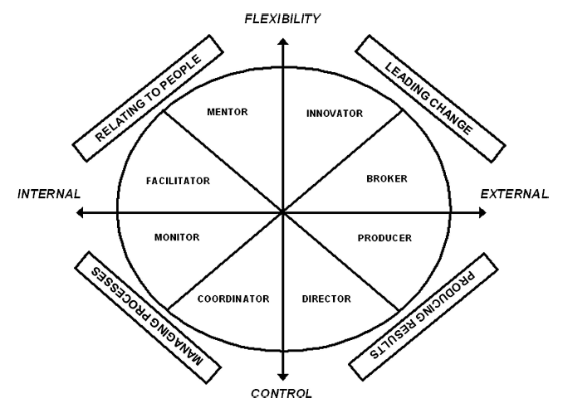
Figure 1: Quinn Model of Leadership Roles (Quinn, 1988)

Table 1: Leadership Quadrants and Role Descriptions (Quinn, 1988)
Quadrant | Leadership Role
Relating to People (RP) | - Mentor: Acknowledges personal needs, develops people, caring, empathetic.  - Facilitator: Acknowledges personal needs, develops people, practices participation and teambuilding, focuses on consensus building, manages conflict and encourages participative decision-making.
Leading Change (LC) | - Innovator: Inspires, anticipates customer needs, initiates significant changes, new ideas, experiments, problem solves, adaptable.  - Broker: Same functions as innovator including, sells ideas, influences decisions at higher levels, acquires needed resources, strong negotiator.
Managing Processes (MP) | - Monitor: Clarifies policies, expects accurate work, control projects, monitors progress, develops measures and checkpoints.  - Coordinator: Same functions as the monitor including brings order, plans schedules, provides stability, control and continuity.
Producing Results (PR) | - Producer: Focuses on outside competition, emphasizes, speed, hard work ethic, motivates, people, initiates action.  - Director: Same functions as producer including providing clear direction, clarifies priorities, communaicates the vision, plans and prioritizes.

Quinn’s Model of Leadership Roles explains that a more effective leader will be able to cover more roles e.g. three to four quadrants of roles in his or her repertoire versus a less effective leader who may only possess one to two quadrants of roles. All the roles covered by a leader co-exist simultaneously within the leader but when facing different situations, certain roles will be demonstrated highly while some opposite roles will be retracted to a minimum degree. In this study, leadership roles are defined as the collection of eight roles which includes facilitator, mentor, innovator, broker, producer, director, coordinator and monitor that an effective project manager can demonstrate appropriately in a complex and rapidly changing environment (Denison et al., 1995).

2.2 Team Satisfaction
Team satisfaction is defined as a project manager’s perception on how team members feel about events within the project team which includes satisfaction with project works, satisfaction with team members and satisfaction with being part of the project team (Dailey, 1993; Nguyen, Seers & Hartman, 2008). This definition is derived from Vroom’s (1964) definition of job satisfaction which refers to a worker’s affective orientation towards his or her work roles. According to Parker and Case (1993) as well as Quick and Nelson (2009), job satisfaction reflects an employee’s overall predisposition towards work and the organization. Employees with positive attitudes are often productive workers. An attitude is an expression of feelings about people, objects, activities and events (Parker & Case, 1993; Quick & Nelson, 2009). Poor attitudes can cause employees to work less effectively and in extreme cases can lead to sabotage or undermine certain processes and systems. Job satisfaction level can be important barometers of morale levels and organizational success (Parker & Case, 1993). Hence, it is important for managers to monitor these barometers. Decreasing morale and job satisfaction levels may be indications of more serious problems of unethical behavior. In this study, it is posited that leadership roles will influence team satisfaction.

Hypothesis 1: Leadership Roles will positively influence Team Satisfaction.

2.3 Team Effectiveness
In this study, Team Effectiveness is defined as the project manager’s perception on team members’ performance in task completion, goal achievement, empowerment, information sharing and team’s ability to create and sustain a good working environment (Bourgault, Drouin & Hamel, 2008). According to Hoevemeyer (1993), there are four reasons that prompted this study to investigate team effectiveness:

(a) effective team will improve job productivity and morale among team members
(b) effective team frees up manager from micro-manage day to day details so that he or she has more time focusing on other works
(c) effective team will enable team work within and between teams so that entire organization can function more effectively
(d) effective team will improve service quality and customer satisfaction.

Based on review of literature, factors like conflict resolution, effective interpersonal communication, trust and leadership can influence team effectiveness (Alexander, 1985; Starcevich, 1993). However, it is not clear whether leadership roles will influence project team effectiveness in the context of Malaysia – and this is one of the intents of this study. Therefore, it is hypothesized that: Hypothesis 2: Leadership Roles will positively influence Team Effectiveness.

2.4 Project Performance
Project performance in this study is based on Stakeholder Requirement Theory which is defined as the degree of project delivery that meets stakeholders’ requirements on a negotiated time, within negotiated budget, meeting specific quality requirements and accepted by customers (Gallegos, Senft, Manson & Gonzales, 2004; Shenhar, 2004; Parsons, 2006). Project performance is used, instead of project success, because project performance only encompasses the stages of planning, production and then handover as indicated by Munns and Bjeirmi (1996) in their stage two to four of the project lifecycle. On the other hand, project success refers to all the six stages from conception, planning, production, handover, utilization to close down. Also according to Pinto and Slevin (1988), project performance is only a subset of project success in which project success also incorporates time, budget, scope, satisfaction, welfare of client, technical and organizational validity as well as contribution to organizational effectiveness. Based on review of literature, supervision influences performance outcomes at the same time as attitudinal and behavioral outcomes (Cohen & Bailey, 1997). Moreover, leader effectiveness comprises of satisfaction, team work and performance in a non-project setting (Yukl, 2010). However, there is still a lack of research on how leadership roles can directly influence project performance in Malaysia.
Hypothesis 3: Leadership Roles will positively influence Project Performance.

3. Methodology
3.1 Sample and Procedure
Based on the deductive research questions of this study, cross sectional quantitative research with online survey method was used. Emails, embedded with a hyperlink to the questionnaire, were sent out to all the 420 target respondents (project managers) from Project Management Institute (PMI) Malaysia Chapter. PMI Malaysia Chapter is a premier representative body of project management in Malaysia and it has the national e-mailing list of experienced and certified project managers. PMI is a global not-for-profit association for project management professionals that have presence in many countries including Malaysia. PMI has over 400,000 members worldwide and it was established in 1969 with headquarter outside Philadelphia, USA (PMI, 2013). The reason for not obtaining responses from project team members is that unlike concentrated project manager’s community which is easily accessible whereby collecting data from previous project team members are challenging as tedious efforts are required to track them. Moreover, this may not be feasible as they may have been disbanded, not contactable or too busy being involved in other projects (Webber, 2002).
Out of the total 420 respondents, only 48% had responded with a useable sample of 201. The sample’s margin of error at 95% confidence is 6.9% based on the formula 0.98/√n whereby “n” is the sample size (i.e. 201). Among the 201 respondents, 79% (n=159) of them were male respondents and 81% (n=162) of them aged between 30 and 49 years. Among the respondents, 62% of them had more than 10 years of project management experience and 93% of them hold a Bachelor or a higher degree. Also, 61% of the respondents were employed in firms with more than 500 employees, while 96% of the respondents were project managers and the balance 4% consisted of project sponsor, quality manager, purchasing director and support manager who were involved in project management.
In the online survey, the respondents were requested to fill up the questionnaire based on a project that they had completed recently, regardless of whether the project outcome was positive or negative. More than half of the projects completed were in chemical / petroleum, construction, financial and information communication technology (ICT) industries which cost more than Ringgit Malaysia five million each. Moreover, 82% of the projects took less than two years to complete and each project has an average of 10 team members.

3.2 Constructs’ Measurement

The following Table 2 depicts the measurement of all the constructs used in this study:

Table 2: Sources of Constructs
No. | Construct | Item Quantity | Scale | Measuring Instruments
1. | Leadership Roles | 16 | 7 pt-Likert | Adapted from Denison et al. (1995)
2. | Team Satisfaction | 7 | 7 pt-Likert | Adapted from Job Descriptive Index (JDI) by Smith, Kendall and Hulin (1969)
3. | Team Effectiveness | 20 | 7 pt-Likert | Adapted from Hoevemeyer (1993)
4. | Project Performance | 8 | 7 pt-Likert | Adapted from Pinto andSlevin (1986); and Mumbi (2007)

In order to measure construct leadership roles, Likert scales (ranging from 1 to 7) with anchors ranging from “Almost Never” to “Almost Always” were used. All other constructs were measured using Likert scales (ranging from 1 to 7) with anchors ranging from “Strongly Disagree” to “Strongly Agree”.

4. Initial Results and Revised Hypotheses
4.1 Reliability and Validity
Partial Least Squares (PLS) were used as part of the statistical analyses in this study. Albeit Cronbach’s Alpha is widely used as an estimator for reliability tests, it has been criticized for its lower bound value which underestimates the true reliability (Peterson & Kim, 2013). Composite Reliability can be used as an alternative as its composite reliability value is slightly higher than Cronbach’s Alpha whereby the difference is relatively inconsequential (Peterson & Kim, 2013). In this study, Composite Reliability and Cronbach’s Alpha for all constructs were above 0.7 which indicated high reliability (see Table 3). Convergent validity was assured in the study because the Average Variance Extracted (AVE) for each construct was higher than 0.5. In Table 4, correlation between pairs of constructs was below 0.9 and the square roots of AVEs (highlighted in bold) were listed in the diagonal line of the table. Correlation between pairs of constructs below 0.9 indicated there was no common method bias (Bagozzi, Yi & Phillips, 1991). Common method bias occurs when there is a variance attributable to the measurement method instead of the constructs that the measures try to represent (Podsakoff, MacKenzie, Lee & Podsakoff, 2003). Any highly correlated constructs are evidence of common method bias whereby usually results in extremely high correlations i.e. more than 0.9 (Bagozzi et al., 1991). All the square roots of AVEs were higher than the correlations between constructs indicated the existence of discriminant validity.

Table 3: Initial Reliability and Average Variance Extracted (AVE)
Construct | Composite Reliability | Cronbach’s  Alpha | AVE
Leadership Roles | 0.90 | 0.87 | 0.60
Team Satisfaction | 0.93 | 0.89 | 0.82
Team Effectiveness | 0.92 | 0.90 | 0.61
Project Performance | 0.93 | 0.91 | 0.68

Table 4: Initial Mean, Standard Deviation, Correlation between Constructs and Squared Roots of AVEs (Diagonal Line)
Construct | Mean | Std Dev | LR | TS | TE | PP
Leadership Roles (LR) | 5.19 | 0.58 | 0.78
Team Satisfaction (TS) | 5.54 | 0.76 | -0.08 | 0.90
Team Effectiveness (TE) | 5.63 | 0.68 | 0.33 | 0.54 | 0.78
Project Performance (PP) | 5.81 | 0.82 | 0.15 | 0.50 | 0.55 | 0.82

4.3 Hypothesis Testing
The SmartPLS v2 was used to perform path analysis in PLS. According to Hsu, Jiang, Parolia and Klein (2007), project team size and project duration can be potential control variables. In order to prevent any possible interference from demographic factors, project team size and project duration were incorporated as control variables. The analysis results were showed in Figure 2. Hypotheses H1 was not supported i.e. Leadership Roles did not influence Team Satisfaction (b = -.01, p > .05). However, Leadership Roles positively influenced Team Effectiveness (b = .33, p < .01). Hence, hypothesis H2 was supported. Hypotheses H3 was not supported i.e. Leadership Roles did not influence Project Performance (b = .16, p > .05). It was also important to note that 12% of the variance in Team Effectiveness was explained by the influence of Leadership Roles. With regards to the two control variables included in the research model, only project team size was significantly related to team satisfaction (b = -.24, p < .05).
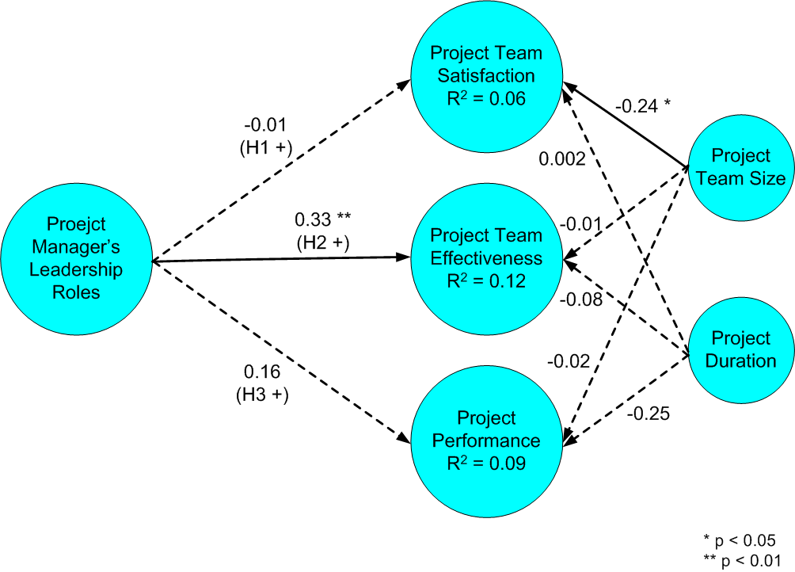
Figure 2: Initial Research Model and Path Analysis Result

Based on the above hypotheses testing, leadership roles positively influenced only team effectiveness – this finding is in contrast to the findings by Cohen and Bailey (1997) in that organizational factors like leadership roles can influence attitudinal outcomes (e.g. team satisfaction), behavioral outcomes (e.g. team effectiveness) and performance outcomes (e.g. project performance) at the same time. According to Porter, Lawler and Hackman (1975), satisfaction is determined by the difference between the amount of valued outcome that a person received and the amount of that outcome s/he feels should receive. In this measure, the larger the difference between the two greater is the dissatisfaction. If there is no change on team members’ expectations, team effectiveness would be the valued outcome received that has potential to improve their team satisfaction.
Based on literature, effectiveness of the top management team presents only an indirect impact on organizational effectiveness whereby its team effectiveness has no bearing on organizational performance (Edmondson, Roberto & Watkins, 2003). According to Parker and Skitmore (2005), team members’ dissatisfaction can increase team members’ turnover which will negatively impact team performance. Also, findings from a study conducted by Fung (2014) found that team satisfaction has potential to influence project performance. Based on the aforementioned review of literature, this has prompted the researcher to adjust the research model by hypothesizing that team effectiveness might positively influence team satisfaction and project performance after the team has become effective. Moreover, it is also hypothesized that the resulted team satisfaction can improve project performance.
Hence, following new hypotheses were developed for the final testing:
- Hypothesis1a: Leadership Roles will positively influence Team Effectiveness
- Hypothesis2a: Team Effectiveness will positively influence Team Satisfaction
- Hypothesis3a: Team Effectiveness will positively influence Project Performance
- Hypothesis4a: Team Satisfaction will positively influence Project Performance

Control variables i.e. project team size and project duration will continue to be deployed in the final testing so that interference from these two demographic factors can be prevented.

5. Final Results
5.1 Reliability and Validity
The following Table 5 presents the final reliability and AVE values for all the constructs. Table 6 presents the final descriptive statistics, correlations and square roots of AVE which are highlighted in bold following the diagonal line.
Table 5: Final Reliability and Average Variance Extracted (AVE)
Construct | Composite Reliability | Cronbach’s  Alpha | AVE
Leadership Roles | 0.88 | 0.83 | 0.59
Team Satisfaction | 0.93 | 0.91 | 0.64
Team Effectiveness | 0.92 | 0.89 | 0.61
Project Performance | 0.93 | 0.91 | 0.66

Table 6: Final Mean, Standard Deviation, Correlation between Constructs and Squared Roots of AVEs (Diagonal Line)
Construct | Mean | Std Dev | LR | TS | TE | PP
Leadership Roles (LR) | 5.19 | 0.58 | 0.77
Team Satisfaction (TS) | 5.54 | 0.76 | 0.13 | 0.80
Team Effectiveness (TE) | 5.63 | 0.68 | 0.37 | 0.65 | 0.78
Project Performance (PP) | 5.81 | 0.82 | 0.18 | 0.59 | 0.57 | 0.81

In the final data analysis, Composite Reliability and Cronbach’s Alpha for all constructs were again above 0.7 which indicated high reliability (see Table 5). Convergent validity was also reassured in the study because the AVE for each construct was higher than 0.5. Based on the results in Table 5, correlation between pairs of constructs was below 0.9 and the square roots of AVEs (highlighted in bold) were listed in the diagonal line of the table. Correlation between pairs of constructs below 0.9 indicated there was no common method bias (Bagozzi et al., 1991). All the square roots of AVEs were higher than the correlations between constructs suggesting a good measure of discriminant validity.

4.3 Hypothesis Testing
The analyses of the final results were showed in Figure 3. All four hypotheses were supported.

- H1a: Leadership Roles positively influenced Team Effectiveness (b = .38, p < .01)
- H2a: Team Effectiveness was positively influencing Team Satisfaction (b = .66, p < .01)
- H3a: Team Effectiveness was positively influencing Project Performance (b = .30, p < .05)
- H4a: Team Satisfaction was positively influencing Project Performance (b = .39, p < .05).

All the path coefficients “b” were greater than 0.1 in which they were considered acceptable according to Lohmoller (1989). Also, 14% of the variance R² in Team Effectiveness was explained by the influence of Leadership Roles. According to Cohen (1988), variance R² of 14%, which had exceeded 13%, was considered moderate. Meanwhile, 44% of the variance R² in Team Satisfaction was explained by both Team Effectiveness and project team size. The 43% of the variance R²in Project Performance was explained by both Team Effectiveness and Team Satisfaction. According to Cohen (1988), respective variance R² of 44% and 43% had exceeded 26% which were considered substantial. Between the two control variables, only project team size was significantly related to Team Satisfaction (b = -.18, p < .05).

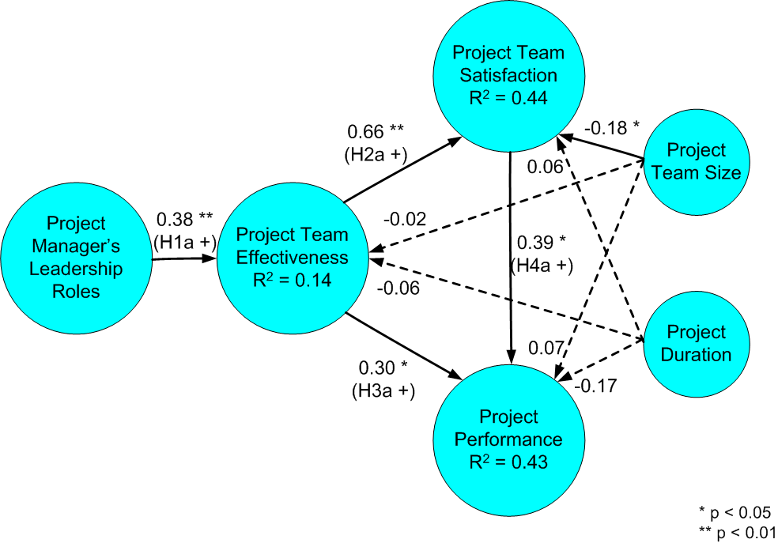
Figure 3: Final Research Model and Path Analysis Result

5. Discussion
When a project manager demonstrates his or her leadership roles frequently, this will lead to an effective team. However, the project manager’s leadership roles do not directly influence team satisfaction and project performance based on the initial results of this study. Insignificant relationship between leadership roles and respective team satisfaction and project performance suggested that leadership roles alone cannot improve these attitudinal and performance outcomes. Based on empirical results of the final research model (see Figure 3 above), effective team can help achieve team satisfaction and improve project performance. Moreover, when the project team is more satisfied, the project team can perform better. In other words, leadership roles can only influence team satisfaction and project performance indirectly through team effectiveness.
There are some lessons to be learnt from this study. Firstly, leadership roles do not directly influence team satisfaction. This finding is in line with what Cohen and Bailey (1997) had suggested that organizational factors (e.g. leadership roles) possess potential to influence attitudinal (e.g. team satisfaction), behavioral (e.g. team effectiveness) and performance (e.g. project performance) outcomes at the same time. One explanation is that team satisfaction and project performance are only developed based on other mediators, rather than being directly influenced by the leadership roles of the project manager. Based on project managers’ experience, team members become more satisfied when they are working in an effective project team rather than witnessing the leadership roles performed by the project manager. In other words, the outcome of team effectiveness is more important that the immediate results of leadership roles. Another possible explanation is that the simultaneous exhibition of different leadership roles which focus on people, processes, changes and results might provide impressions to project team that the project manager is changing his or her mind rather fast; and thus, satisfaction within the team becomes more difficult to nurture. Moreover, since the project timeline is on a temporary basis, this will pose further challenge to timely develop team satisfaction while the project manager is leading with various roles concurrently.
Secondly, leadership roles also did not directly influence the project performance. The possible explanation is that project performance is directly dependent on other factors, but not on leadership roles. For example, project success is not directly dependent on project manager’s leadership styles, but rather directly dependent on the project manager’s perception of success and emotional intelligence (Lee-Kelley, Leong & Loong, 2003; Turner & Muller, 2005). Moreover, according to Lo, Ramayah and Run (2010), inconclusiveness of the most widely practiced leadership style in Malaysia suggests that project managers need to explore and identify the appropriate intervening factors like self-perception, emotional intelligence or others – which is an important measure that can mediate the relationship between leadership roles and project performance.
Thirdly, effective project team leads to team satisfaction. Since team satisfaction is contingent on both the expected and actual outcome received (Porter et al., 1975), higher team effectiveness will generate higher actual outcome received, and this in return will lead to higher team satisfaction. Moreover, the improved team effectiveness can increase team satisfaction as effective team can develop esprit de corps and coordinate better. The fourth lesson learnt is that effective project team can improve project performance. The explanation is that effective team will perform better in the project as the team members generally are more independent yet capable to work together as a team, disciplined, productive, focusing on work quality and striving to satisfy the customer (Hoevemeyer, 1993).
Lastly, team satisfaction can also improve project performance. When the effective team is happier the team can deliver better project performance. Reason being when the effective team is satisfied, incidents like team conflict, team members’ absenteeism and turnover will be at minimum in which helps the team to maximize the project performance. With regards to the two control variables included in the study, only project team size negatively influences team satisfaction. This finding indicates that larger the project team size, higher the team dissatisfaction. This might due to larger the team size, communication problem and conflict within the team are more prevalent. This is why some project managers prefer to keep the team size not too large so that it is under control. Moreover, inclusion of these two control variables also indicaes that relationships among leadership roles, team satisfaction, team effectiveness and project performance in this study are free from the interference of team size and project duration.
In answering the first research question on whether leadership roles directly and simultaneously influences team satisfaction, team effectiveness and project performance, this study indicated that leadership roles only influences team effectiveness directly, and not the other variables. As for the second research question, this study demonstrated that after leadership roles have influenced team effectiveness, the team effectiveness in turn can influence both team satisfaction and project performance concurrently. Moreover, after the team satisfaction is achieved, it can also influence the project performance directly.

6. Conclusion
Based on the research conducted by Cohen and Bailey (1997), this study has provided further understanding on how attitudinal, behavioral and performance outcomes are interrelated when an organizational factor is present. Since there are many outcome instances in each category of attitudinal, behavioral and performance outcomes, it is proposed to select the relevant outcome instances for research from each category before evaluating the dependencies of attitudinal, behavioral and performance outcomes. In this study, organizational factor (represented by leadership roles) had impacted behavioral outcome (team effectiveness). In return, the behavioral outcome had impacted both attitudinal (team satisfaction) and performance (project performance) outcomes. Moreover, the attitudinal outcome also impacted the performance outcome (see Figure 3 above). This study also suggests for project managers or management teams to emphasize more on leadership roles during their tenure serving as project managers. This is because appropriate and frequent demonstration of these leadership roles will yield benefits which include team effectiveness, team satisfaction and project performance.
However, this study is not without its limitations. Firstly, this study only solicited the perceptions from project managers. Future study can include project team members as part of the respondents to evaluate their view points as well. Secondly, only one instance was chosen from respective three categories of outcomes as stipulated by Cohen and Bailey (1997) i.e. team satisfaction representing attitudinal outcomes, team effectiveness for behavioral outcome and project performance for performance outcomes. Future studies can include other different instances or group of instances from the same categories of outcomes to form a separate research model. For example, attitudinal outcomes can include team trust, team commitment or others. Behavioral outcomes can include team cohesion, team conflict, absenteeism, turnover or others. Performance outcomes can include quality of works, return on investment, market share or others. Thirdly, qualitative interview and data analysis can be performed in future with some of the surveyed project managers. This is to understand how and why leaderships directly influenced, or did not directly influence, team satisfaction and project performance as this can generate deeper insight for knowledge contribution. In conclusion, this study has contributed a small step into deeper understanding on how leadership roles influences attitudinal, behavioral and performance outcomes in Malaysia.

References
Alexander, M. (1985). The Team Effectiveness Critique, The 1985 Annual: Developing Human Resources. University Associates. Available at: http://74.125.153.132/search?q=cache:AFYkkxqZX1cJ:myeducationmanager.com/Ebooks/THE_TEAM_EFFECTIVENESS_CRITIQUE.doc+Mark+Alexander+the+team+effectiveness+critique&cd=1&hl=en&ct=clnk&gl=my (Accessed January 2010).
Bagozzi, R. P., Yi, Y., & Phillips, L. W. (1991). Assessing Construct Validity in Organizational Research. Administrative Science Quarterly, 36, 421-458.
Belbin, M. (1993). Team Roles at Work. Oxford: Butterworth/Heinemann.
Bourgault, M., Drouin, N., & Hamel, E. (2008). Decision making within distributed project teams: An exploration of formalization and autonomy as determinants of success. Project Management Journal, 39, Supplement, S97-S110.
Chen, C. C., Wu, J., Yang, S. C., & Tsou, H.-Y. (2008). Importance of Diversified Leadership Roles in Improving Team Effectiveness in a Virtual Collaboration Learning Environment. Educational Technology & Society, 11(1), 304-321.
Cohen, J. (1988). Statistical power analysis for the behavioral sciences (2nd ed.), Hillsdale, Lawrence Erlbaum Associates, NJ.
Cohen, S. G., & Bailey, D. E. (1997). What Makes Teams Work: Group Effectiveness Research from the Shop Floor to the Executive Suite. Journal of Management, 23(3), 239-290.
Dailey, R. C. (1993). Organizational Behavior, Pitman Publishing, 15-21.
Denison, D. R., Hooijberg, R., & Quinn, R. E. (1995). Paradox and performance: Toward a theory of behavioral complexity in managerial leadership. Organization Science, 6 (5), 524-540.
Edmondson, A. C., Roberto, M. A., & Watkins, M.D. (2003). A dynamic model of top management team effectiveness: Managing unstructured task streams. The Leadership Quarterly, 14(2003), 297-325.
Fung, H.-P. (2014). Relationships between Leadership Roles and Project Team Effectiveness as Perceived by Project Managers in Malaysia. Journal of Empirical Studies, 2014, 1(1), 1-22.
Gallegos, F., Senft, S., Manson, D. P., & Gonzales, C. (2004). Information technology control and audit (2nd ed.).Boca Raton, FL: Auerbach.
Gunnar,G., &Torodd, S. (1999). Organizational Types and Leadership Roles. Scandinavian Journal of Management, 15(4): 385-403.
Hoevemeyer, V. A. (1993). How effective is your team? Training and Development, 47(9), 67-71.
Hsu, J. S. C., Jiang, J. J., Parolia, N., & Klein, G. (2007). The Impact of Team Mental Models on IS Project Teams’ Information Processing and Project Performance.eProceedings of the 2nd International Research Workshop on Information Technology Project Management (IRWITPM), Montreal, Quebec, Canada.
Jessup, H. R. (1990). New Roles in Team Leadership. Training and Development Journal, 44(11): 79-83.
Lee-Kelley, L., Leong, K., & Loong. (2003). Turner’s five functions of project-based management and situational leadership in IT services projects. International Journal of Project Management, 21(8), 583-591.
Lo, M.-C., Ramayah, T., & Run, E. C. (2010). Testing Multi-Dimensional Nature of “New Leadership” in a non-Western Context: The Case of Malaysia. Journal of Organizational Culture, Communications and Conflict, 14(2), 61-73.
Lohmoller, J.-B. (1989). Latent variable path modeling with partial least squares. Heidelberg, Germany: Physica-Verlag.
Mintzberg, H. (1973). The Nature of Managerial Work. New York: Harper & Row.
Mumbi, C. K. (2007). An Investigation of the Role of Trust in Virtual Project Management Success. PhD Thesis, Murdoch University, Australia.
Munns, A. K., &Bjeirmi, B. F. (1996). The Role of Project Management in Achieving Project Success. International Journal of Project Management, 14(2), 81-87.
Neuhauser, C. (2007). Project Manager Leadership Behaviors and Frequency of Use by Female Project Managers. Project Management Journal, 38(1), 21-31.
Nguyen, N. T., Seers, A., & Hartman, N. S. (2008). Putting a Good Face on Impression Management: Team Citizenship and Team Satisfaction. Journal of Behavioral and Applied Management, 9(2), 148-168.
Parker, C., & Case, T. (1993). Management Information Systems: Strategy and Action. Mitchell McGRAW-HILL, Watsonville, CA.
Parker, S. K., &Skitmore, R. M. (2005). Project Management Turnover: Causes and Effects on Project Performance. International Journal of Project Management, 23(3): pp. 205-214.
Parsons, V. S. (2006). Project performance: How to access the early stages. Engineering Management Journal, 18(4), 11-15.
Peterson, R. A., & Kim, Y. (2013). On the Relationship between Coefficient Alpha and Composite Reliability. Journal of Applied Psychology,98(1), 194-8. DOI:10.1037/a0030767
Pinto, J. K. (2007). Project Management: Achieving Competitive Advantage. Pearson Education, Inc., New Jersey.
Pinto, J. K., &Slevin, D. P. (1986). The Project Implementation Profile: New Tool for Project Managers. Project Management Journal, 17(4), 57.
Pinto, J. K., &Slevin, D. P. (1988). Critical Success Factors in Effective Project Implementation. Project Management Handbook, D.I. Cleland and W.R. King, New York, Van Nostrand Reinhold: 479-512.
Podsakoff, P.M., MacKenzie, S. B., Lee, J. Y., &Podsakoff, N. P. (2003). Common Method Biases in Behavioral Research: A Critical Review of the Literature and Recommended Remedies. Journal of Applied Psychology, 88(5), 879-903.
Porter, L. W., Lawler, E. E. III, & Hackman, J. R. (1975). Behavior in Organizations. McGraw-Hill Book Company.
Prabhakar, G. (2005). Switch Leadership in Projects. Project Management Journal, 36(4), 53-60.
Project Management Institute (2013). A Guide to the Project Management Body Of Knowledge (PMBOK guide) – 5th Edition, Newtown Square, PA: Project Management Institute, Inc.
Quick, J. C., & Nelson, D. L. (2009). Principles of Organizational Behavior – Realities and Challenges (6th ed.). South-Western, Cengage Learning.
Quinn, R. E. (1988). Beyond Rational Management: Mastering the Paradoxes and Competing Demands of High Performance,Jossey-Bass, Inc., San Francisco.
Shanahan, P. (2001). Mapping team performance shaping factors. QinetiQ, Fort Halstead.
Shenhar, A. J. (2004). Strategic project leadership: Toward a strategic approach to project management, R&D Management, 34(5), 569-578.
doi:10.1111/j.1467-9310.2004.00363.x
Smith, P. C., Kendall, L. M., & Hulin, C. L. (1969). The measurement of satisfaction n work and retirement, Skokie, IL: Rand McNally.
Starcevich, M. M. (1993). A Model of an Effective Team. Available at: http://www.learningunlimited.com/uploads%5C270.pdf (Accessed January 2010).
Stephen, S. P. (1998). Cross-Cultural Team Building: The Impact of Leadership and Technology on an Industrial Project in West Africa. Dissertation, The Fielding Institute, page 143.
Turner, J. R., & Muller, R. (2005). The Project Manager’s Leadership Style as a Success Factor on Projects: A Literature Review. Project Management Journal, 36(1), 49-61.
Vroom, V. H. (1964). Work and Motivation. New York: John Wiley and Sons, 99.
Wakefield, R. L., Leidner, D. E., & Garrison, G. (2008). A Model of Conflict, Leadership, and Performance in Virtual Teams. Information Systems Research, 19(4), 434-455.
Webber, S. S. (2002). Leadership and Trust Facilitating Cross-Functional Team Success. Journal of Management Development, 21(3), 201-214.
Yukl, G. (2010). Leadership in organizations (7th ed.). Upper Saddle River, NJ: Prentice-Hall.
Zafft, C. R., Adams, S. G., &Matkin, G. S. (2009). Measuring Leadership in Self-Managed Teams Using the Competing Values Framework. Journal of Engineering Education, July 2009, 273-282.

